**Chapter 1**

**Introduction**

* 1. **Introduction**

In this digital world, most people are prone to diseases, due to a lack of healthy food, proper sleep, and daily exercise. It is very crucial to know if we are suffering from a disease, at an early stage rather than discovering it at a later stage.

According to recent reports many young people from the age groups of 25-35 are suffering from heart attack. Hence heart disease prediction system plays an important role as it predicts diseases based on symptoms. This cardiovascular disease prediction system uses machine learning algorithms like Random Forest, Logistic regression, SVM, Naïve Bayes, Decision tree classifier, Neural Network, MLP, Perceptron, KNN. This system also suggests the amount of risk that a person has.

With the advancement in technology, Machine Learning is becoming more popular and commonly used technology by industry experts for solving problems faced in real life. Machine Learning is the scientific study of algorithms and statistical models that computer uses to perform a specific task without using explicit instructions, relying on patterns and inference instead. Machine Learning is also used by the healthcare industry to bring advancement in their techniques so that they can provide better services to their patients. The heart disease prediction system predicts the severity of the diseases based on the patient’s symptoms.

* 1. **Choice of Topic with reasoning/Need of Project**

The rationale for choosing this topic is that Heart Disease Prediction systems have the potential to greatly help the society to predict any kind of heart disease. Additionally, Heart Disease prediction systems can provide valuable insights to user. Nowadays, the younger generation is also facing the Heart problems due to lack of awareness and knowledge related to heart disease.

The idea behind the project is that this system can help people discover a disease that they are suffering from. Additionally, Heart Disease Prediction systems can help to promote the awareness of dangerous Diseases. Prediction systems are a valuable tool for both medical field professionals and Society.

The study will identify and analyze symptoms and identify major heart diseases from symptoms which people mostly neglect. In addition, the study will also identify and analyze the minor issues and challenges associated with disease prediction. The project aims to predict the severity of heart disease that a person is suffering from.

* 1. **Problem Statement**

The WHO reports that heart-related disorders are on the rise. Due to this, 17.9 million individuals pass away annually. Many people neglect early signs of illnesses that, in the long run, can be fatal. There are instruments that can predict heart disease, but they are either expensive or ineffective at estimating the likelihood that heart disease will occur in humans. They also do not provide a risk percentage related to the disease. Calculating the risk of the disease is just as crucial as diagnosing it. The project provides an implementation of machine learning for identifying heart diseases and understanding the risk percentage at an early stage.

**Chapter 2**

**Proposed System**

**2.1 Objectives**

1. To Study existing system.
2. To make use of common clinical data to create a high-performing and economical ML-based heart disease prediction system
3. To provide risk percentage.
4. To compare the performance between previous and existing system.
   1. **Requirement Engineering**

To study the system, you need to collect facts. Facts are expressed in qualitative form called as data. Success of any requirement any investigation depends upon availability of accurate and reliable data. These depend on appropriate method chosen for data collection. The specific methods used for collecting data are fact finding techniques.

**The different methods used by analyst are:**

Interview

Onside

Observation

Record

Review

Questionary

**In this project I am using the method of:**

**Interview:**

Interview technique is used to collect information from individual or from groups. Analyst should select respondent how are related to system under study. In this method interviewer that is analyst seats face to face with respondent and record his responses.

The information collected is likely to be more accurate and reliable because the interviewer can clear up their doubts and crass check the despondence. This method also helps to find the area of misunderstanding, unrealistic expectations and future problems of the prose system.

**Observation**:

Unlike the other fact-finding technique, in this method the analyst himself visits the organization on observes and understands the flow of document, working of requirement system, the users of the system etc. For this method to be adopted it takes and analyst to perform this job as he knows which points should be noticed and highlighted. In analyst may observe the unwanted things as well and simply cause delay in the development of the new system.

* 1. **Requirement Gathering**

The waterfall model is a sequential (non-iterative) design process, used in software development process, in which process is seen as flowing steadily downwards (like a waterfall) through the phases of conception, initiation, analysis, design, construction, testing, production/implementation & maintenance. Despite the development of new software development process models, the waterfall model is still the dominant process model with over a third of software developers still using it.

* 1. **Software Requirement**

The software requirements are description of features and functionalities of the target system. SRS defines how the intended software will interact with hardware, external interfaces, speed of operation, response time of system, portability of software across various platforms, maintainability, speed of recovery after crashing, Security, Quality, Limitations etc. It is the responsibility of system analyst to document the requirements in technical language so that they can be comprehended and useful by the software development team.

SRS should come up with following features:

* User Requirements are expressed in natural language.
* Technical requirements are expressed in structured language, which is sued inside the organizations.
* Design description should be written in Pseudo code.
* Format of Forms and GUI screen prints.
* Conditional and mathematical notations for DFDs etc.
* Technical requirements are expressed in structured language.
* Format of Forms and GUI screen prints.

Broadly software requirements should be categorized in two categories:

**Functional Requirements:**

Requirements, which are related to functional aspect of software fall into this category. They define functions and functionality within and from the software system.

**Non-Functional Requirements:**

Requirements, which are not related to functional aspect of software, fall into this category. They are implicit or expected characteristics of software, which users make assumption of.

**Software Requirement:**

**What is Flask?**

Flask is a web application framework written in Python. It was developed by Armin Ronacher, who led a team of international Python enthusiasts called Pocco. Flask is based on the Werkzeg WSGI toolkit and the Jinja2 template engine. Both are Pocco projects.

Flask is a web framework, it’s a Python module that lets you develop web applications easily. It has a small and easy-to-extend core: it’s a microframework that doesn’t include an ORM (Object Relational Manager) or such features. It does have many cool features like URL routing, template engine. It is a WSGI web app framework.

**WSGI:** The Web Server Gateway Interface (Web Server Gateway Interface, WSGI) has been used as a standard for Python web application development. WSGI is the specification of a common interface between web servers and web applications.

**Werkzeug:** Werkzeug is a WSGI toolkit that implements requests, response objects, and utility functions. This enables a web frame to be built on it. The Flask framework uses Werkzeg as one of its bases.

**Database Requirement:**

**Introduction to MySQL server:**

* MySQL is a relational database management system.
* MySQL is open-source.
* MySQL is free.
* MySQL is ideal for both small and large applications.
* MySQL is very fast, reliable, scalable, and easy to use.
* MySQL is cross-platform.
* MySQL is compliant with the ANSI SQL standard.
* MySQL was first released in 1995.

**Features of MYSQL Server:**

Open Source

Quick and Reliable

Scalable

Data Types

Character Sets

Secure

Supports Large Databases

**Chapter 3**

**System Analysis**

* 1. **System Designs**

The system design consists of machine learning model in the backend while the frontend is a website wherein users can enter their details in order to get the output.

**System Architecture**

* **Chatbot Service***:* Using this service users will register with a web application and have the option to use a chatbot to get an automatic response from the trained question and answer data. The chatbot will be trained using LSTM and dialog flow.
* **Online Analysis***:* The users will receive an analysis of their reports with the help of the website. Once they enter their report details into the interface, they will receive the analysis and the risk percentage.

The system design is as follows –

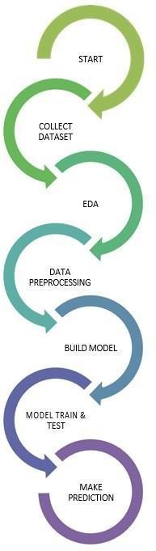

* **Collecting dataset** – This step involves collecting dataset manually which I referred from various sources. The dataset contains 7k values.
* **EDA** – This phase involves understanding the dataset and using libraries like matplotlib and seaborn to visualize the variables in the dataset.
* **Data preprocessing** – In this phase we removed and cleaned the dataset to remove all the null values. The processing of categorial values is also done in this step
* **Building model** – In this step we build a model using several algorithms. The algorithms that we have used in this project are Logistic Regression, SVM, KNN, Random Forest, Naïve Bayes, Neural Network, MLP, Perceptron and Decision Tree Classifier.
* **Model train and test** – In this step we train and test the dataset by firstly splitting it in a specific ratio. We have split our dataset using sklearn library in the ratio of 1:4, i.e., 80% of data for training and remaining 20% for testing.
* **Making prediction** – After making sure that the model works properly for while testing it, we can deploy the model for making predictions. For this, we are going to create a website containing fields for taking information from the user. From the values entered by the user the model will make further predictions.
  1. **Methodology/Algorithm**
     1. **Logistic Regression**

Independent variables are analyzed to determine the binary outcome with the results falling into one of two categories. The independent variables can be categorical or numeric, but the dependent variable is always categorical.

In logistic regression, we fit a "S" shaped logistic function, which predicts two maximum values, rather than a regression line (0 or 1).

The logistic function's curve shows the possibility of several things, including whether or not the cells are malignant, whether or not a mouse is obese depending on its weight, etc.

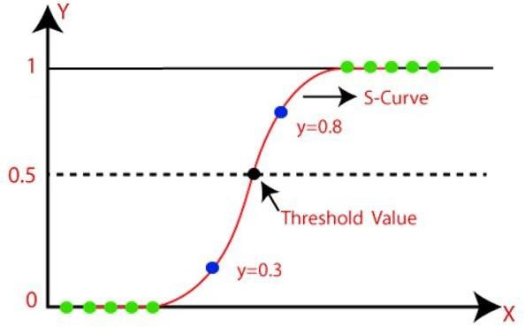Because it can classify new data using both continuous and discrete datasets, logistic regression is a key machine learning approach.

Fig. Logistic Regression

* + 1. **K-Nearest Neighbors**

K-nearest neighbors (k-NN) is a pattern recognition algorithm that uses training datasets to find the k closest relatives in future examples. When k-NN is used in classification, you calculate to place data within the category of its nearest neighbor. If k =1, then it would be placed in the class nearest 1. K is classified by a plurality poll of its neighbors.

The K-NN algorithm assumes that the new case and the existing cases are comparable, and it places the new instance in the category that is most like the existing categories.

A new data point is classified using the K-NN algorithm based on similarity after all the existing data has been stored. This means that utilizing the K-NN method, fresh data can be quickly and accurately sorted into a suitable category.

It is also known as a lazy learner algorithm since it saves the training dataset rather than learning from it immediately. Instead, it uses the dataset to perform an action when classifying data.

The KNN method simply saves the information during the training phase, and when it receives new data, it categorizes it into a category that is quite like the new data.

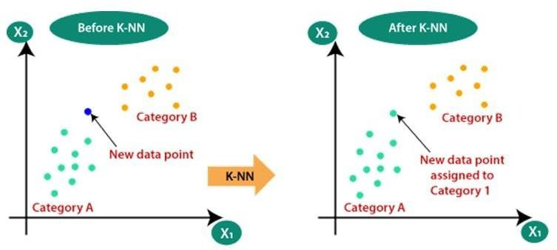

Fig. K-Nearest Neighbors

* + 1. **Random Forest**

The random forest algorithm is an expansion of decision tree, in that you first construct a multitude of decision trees with training data, then fit your new data within one of the trees as a “random forest”. It, essentially, averages your data to connect it to the nearest tree on the data scale.

Popular machine learning algorithm Random Forest is a part of the supervised learning methodology. It can be applied to ML issues involving both classification and regression. It is built on the idea of ensemble learning, which is a method of integrating various classifiers to address difficult issues and enhance model performance.

Random Forest, as the name implies, is a classifier that uses a number of decision trees on different subsets of the provided dataset and averages them to increase the dataset's predictive accuracy. Instead, then depending on a single decision tree, the random forest uses forecasts from each tree and predicts the result based on the votes of the majority of predictions.

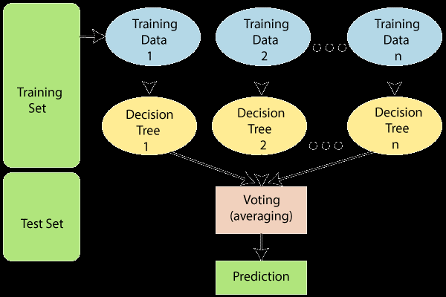

Fig. Random Forest

For the dataset’s feature variable to predict true outcomes rather than a speculated result, there should be some actual values in the dataset.

* + 1. **Decision Tree**

A decision tree is a supervised learning algorithm that is perfect for classification problems, as it’s able to order classes on a precise level. It works like a flow chart, separating data points into two similar categories at a time from the “tree trunk” to “branches,” to “leaves,” where the categories become more finitely similar. This creates categories within categories, allowing for organic classification with limited human supervision.

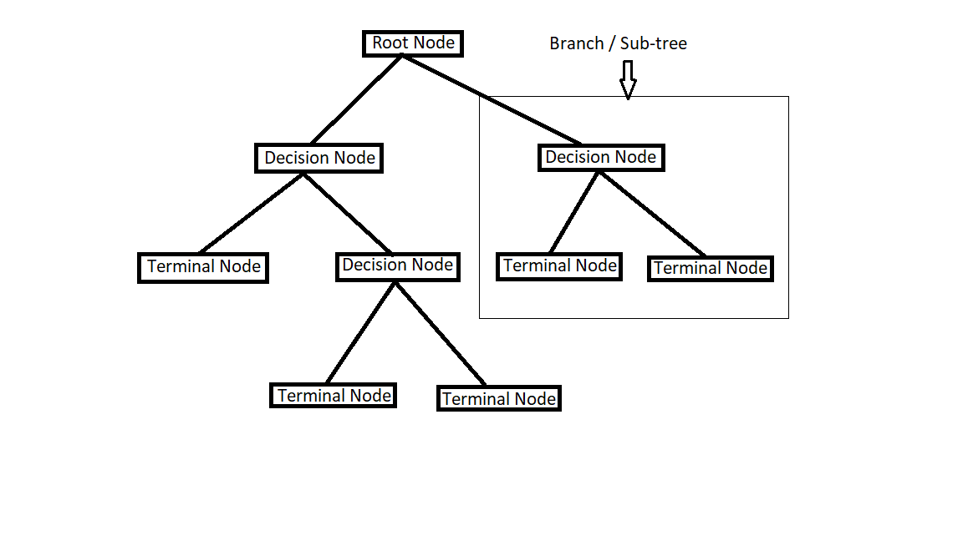

Fig. Decision Tree

* + 1. **Support Vector Machine**

A support vector machine (SVM) uses algorithms to train and classify data within degrees of polarity, taking it to a degree beyond X/Y prediction. The SVM algorithm's objective is to establish the best line or decision boundary that can divide n-dimensional space into classes, allowing us to quickly classify fresh data points in the future. A hyperplane is the name given to this optimal decision boundary. SVM selects the extreme vectors and points that aid in the creation of the hyperplane. Support vectors, which are used to represent these extreme instances, form the basis for the SVM method.

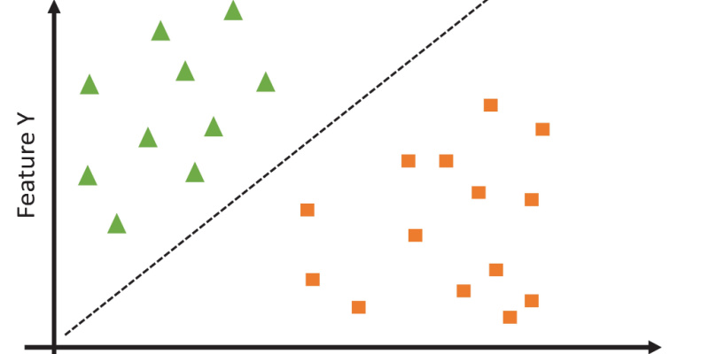

Fig. Support Vector Machine

* + 1. **Naïve Bayes**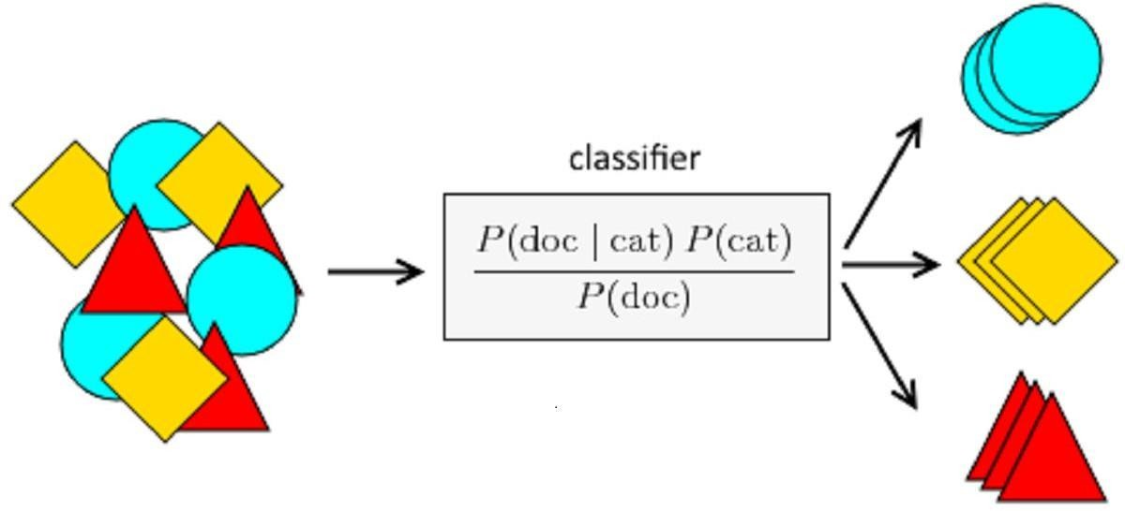

Fig. Naïve Bayes

This algorithm is a supervised learning method for classification issues that is based on the Bayes theorem. It is mostly employed in text categorization with a large training set. The Naive Bayes Classifier is one of the most straightforward and efficient classification algorithms available today.It aids in the development of quick machine learning models capable of making accurate predictions. Being a probabilistic classifier, it makes predictions based on the likelihood that an object will occur. The Bayes theorem, also referred to as Bayes' Rule or Bayes' law, is used to calculate the likelihood of a hypothesis given some prior information. The conditional probability determines this.

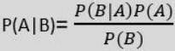

P(A|B) is Posterior probability: Probability of hypothesis A on the observed event B.

P(B|A) is Likelihood probability: Probability of the evidence given that the probability of a hypothesis is true.

P(A) is Prior Probability: Probability of hypothesis before observing the evidence.

P(B) is Marginal Probability: Probability of Evidence.

We are going to implement the above given algorithms and choose one that gives the highest accuracy for making predictions.

* 1. **Data Flow Diagram** 
     1. **Context Level DFD**



* + 1. **First Level DFD**



* 1. **Entity Relationship Diagram (ERD)**



* 1. **Use Case Diagram**

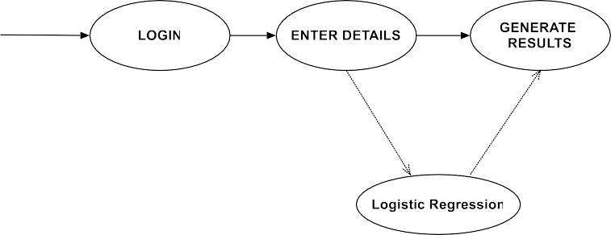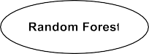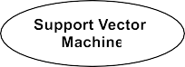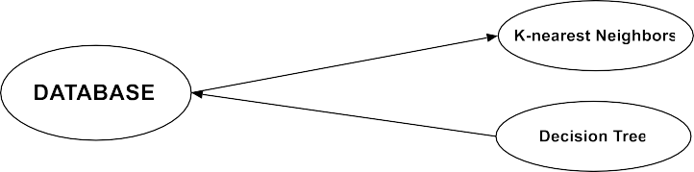

* 1. **State Diagram**

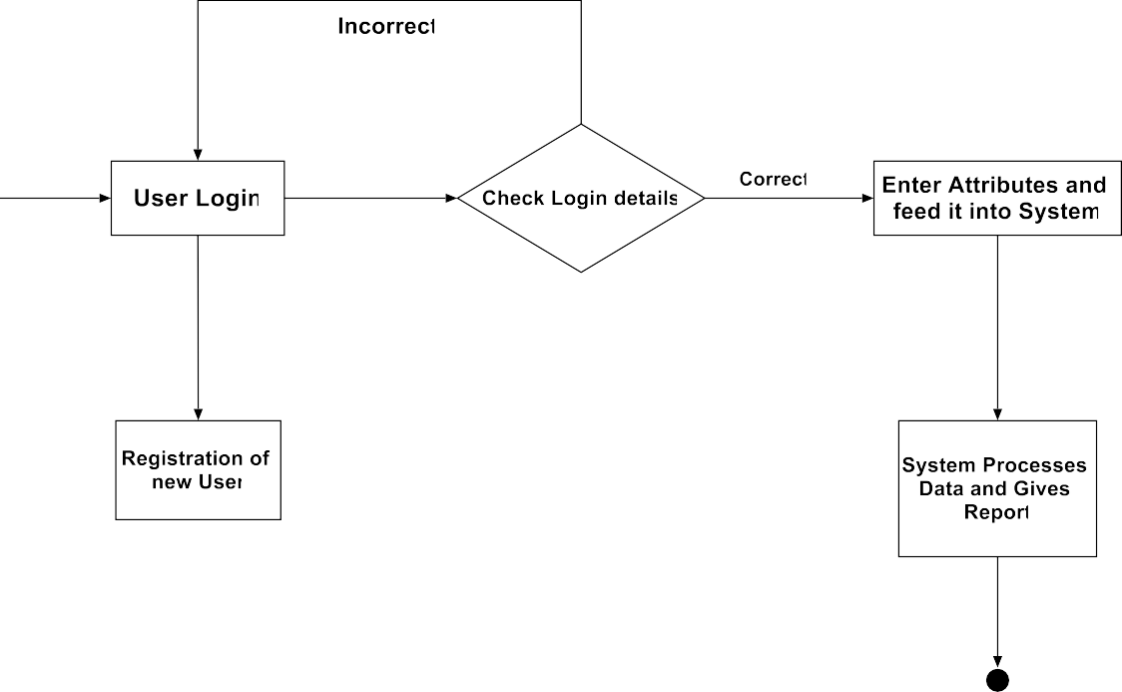

* 1. **Sequence Diagram**

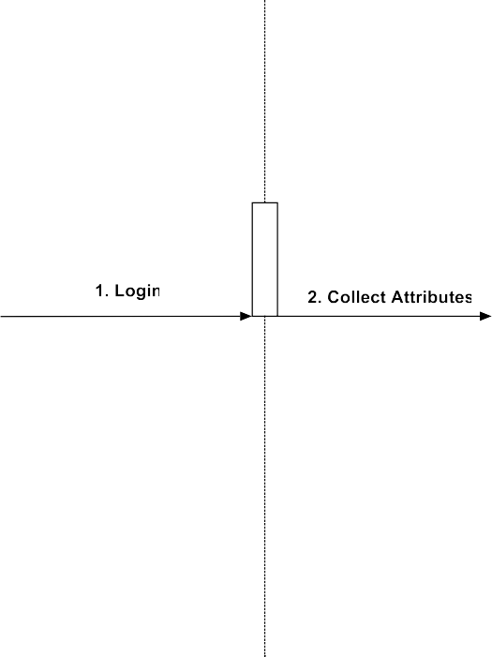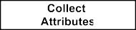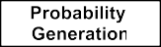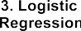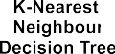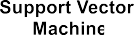

* 1. **Deployment Diagram**

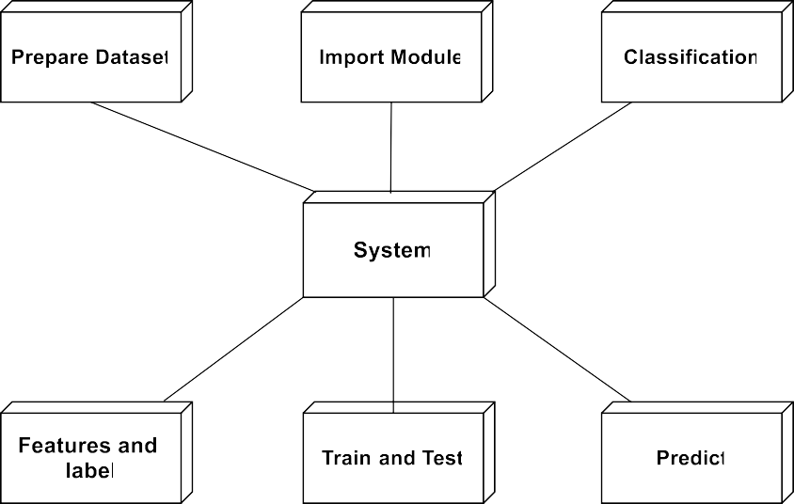

* 1. **Activity Diagram**

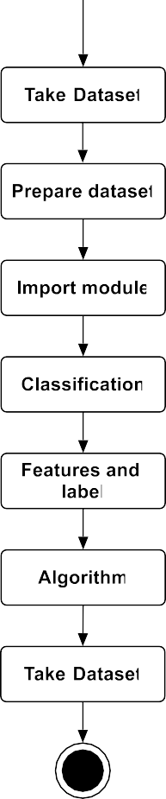

**Chapter 4**

**System Design**

**4.1 Database Design**

1. **User Registration**

|  |  |  |  |  |  |
| --- | --- | --- | --- | --- | --- |
| **Field** | **Type** | **Null** | **Key** | **Default** | **Extra** |
| Username | Varchar(255) | No | Primary Key | Null |  |
| Emailid | Varchar(255) | Yes |  | Null |  |
| Password | Varchar(255) | Yes |  | Null |  |

1. **Details**

|  |  |  |  |  |  |
| --- | --- | --- | --- | --- | --- |
| **Field** | **Type** | **Null** | **Key** | **Default** | **Extra** |
| Did | Int | No | Primary Key | Null | Auto_increment |
| Age | Int | Yes |  | Null |  |
| Gender | Int | Yes |  | Null |  |
| Height | Int | Yes |  | Null |  |
| Weight | Int | Yes |  | Null |  |
| BP Lo | Int | Yes |  | Null |  |
| Bp Hi | Int | Yes |  | Null |  |
| Cholesterol | Int | Yes |  | Null |  |
| Heartrate | Int | Yes |  | Null |  |
| Smoke | Int | Yes |  | Null |  |
| Alcohol | Int | Yes |  | Null |  |
| Physical | Int | Yes |  | Null |  |
| Cardio | Int | Yes |  | Null |  |

**4.2 Input Design**

1. **Registration:**

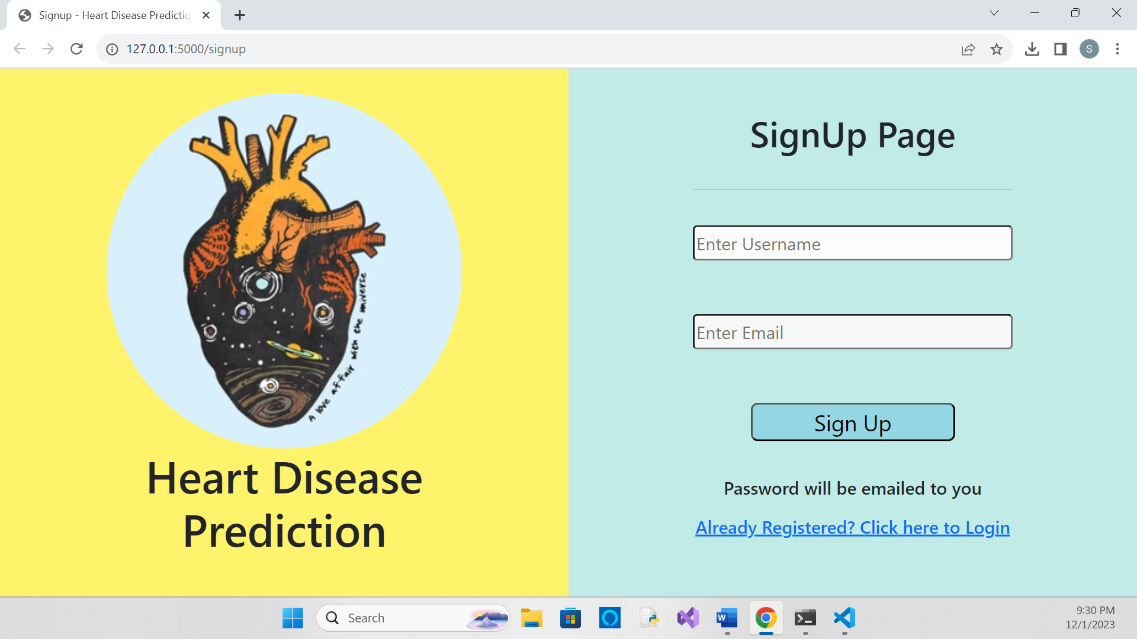

**Providing the Inputs:**

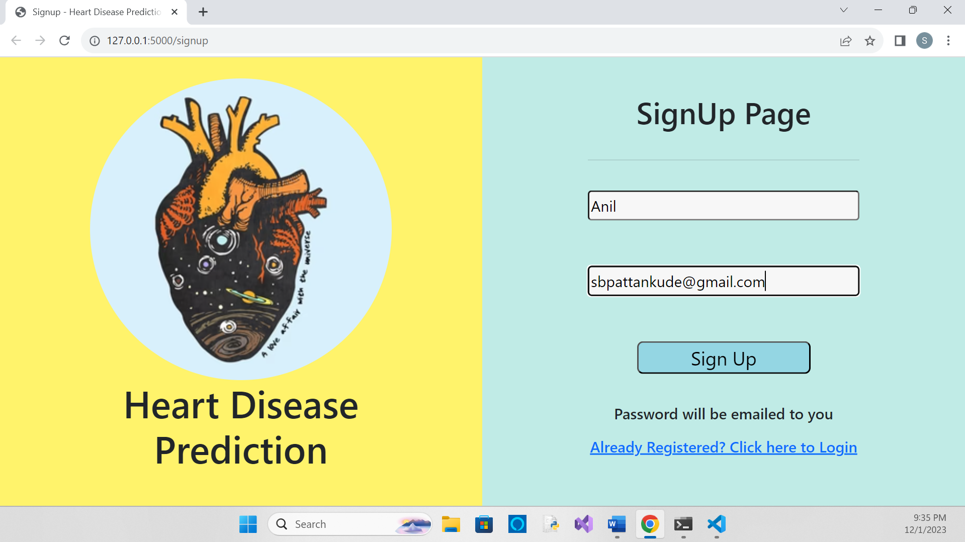

**After submitting the input:**

(Redirected to Login page as password was mailed on given email id)

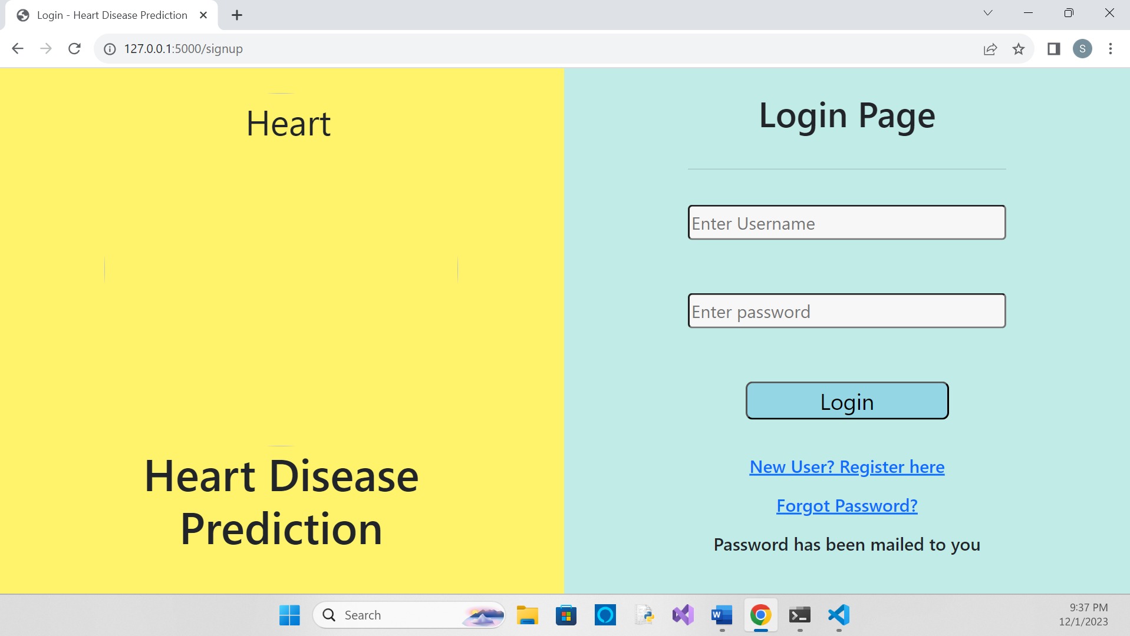

1. **Home page:**

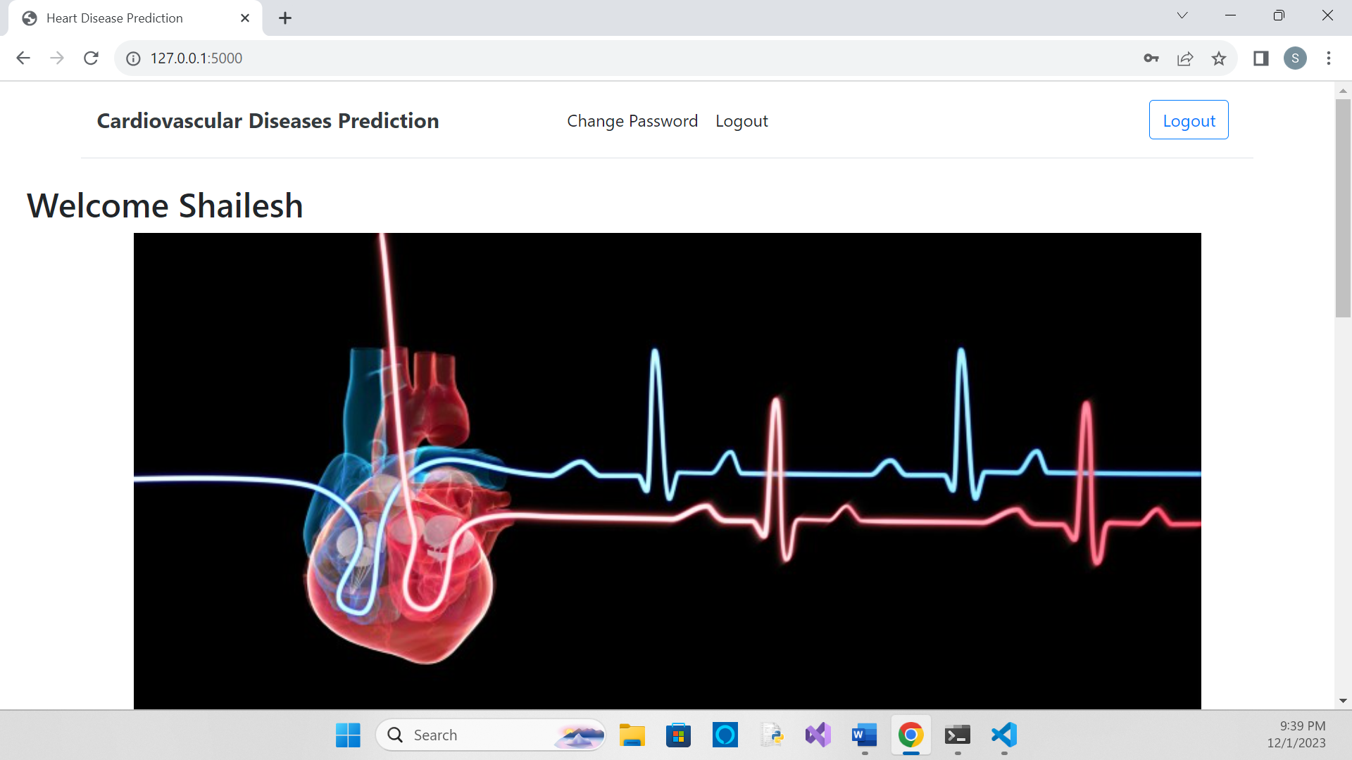

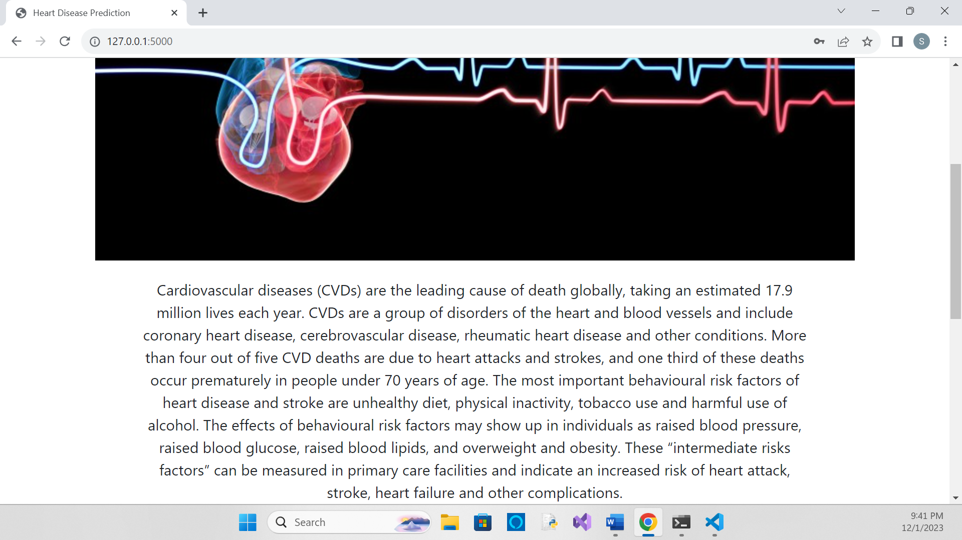

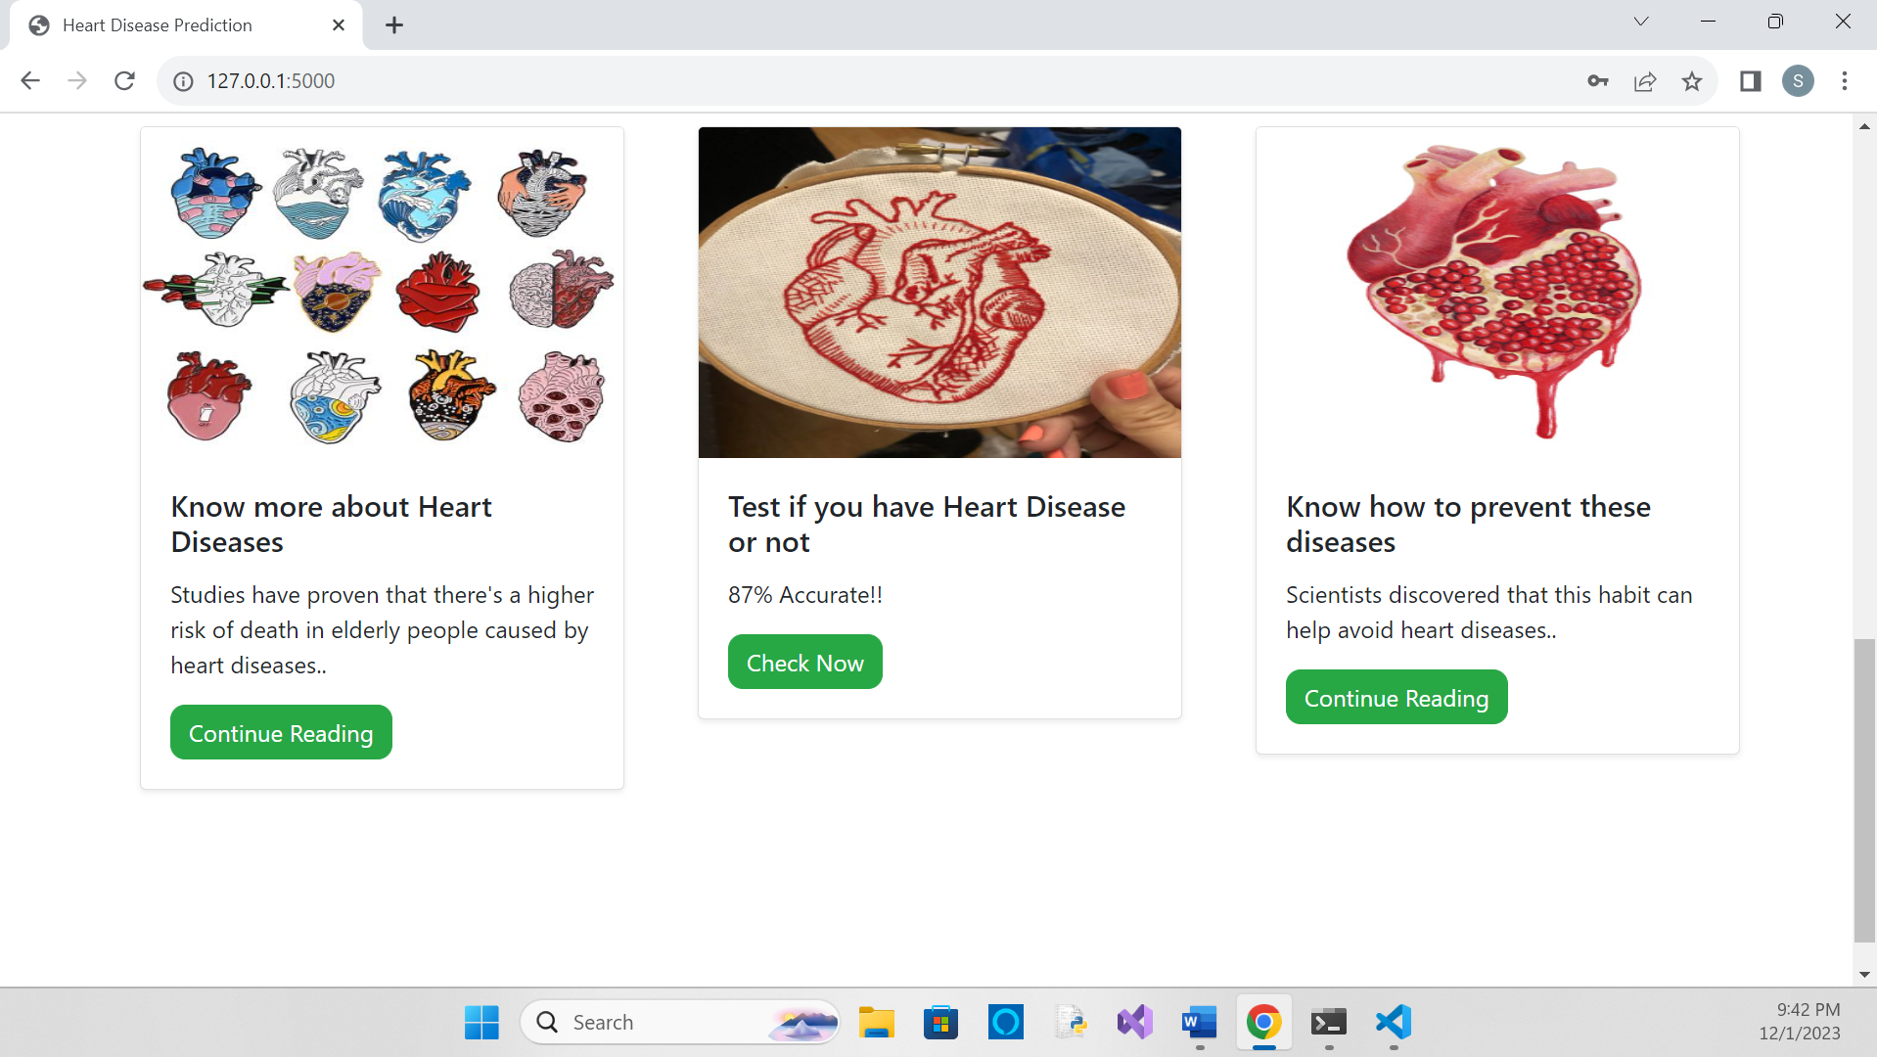

1. **Prediction Form:**

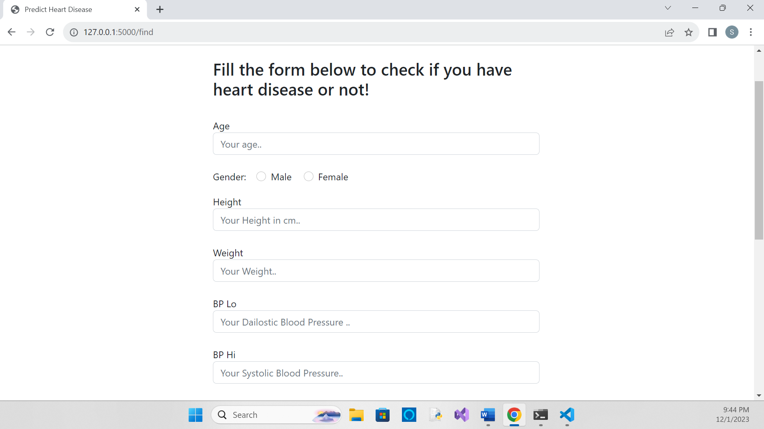

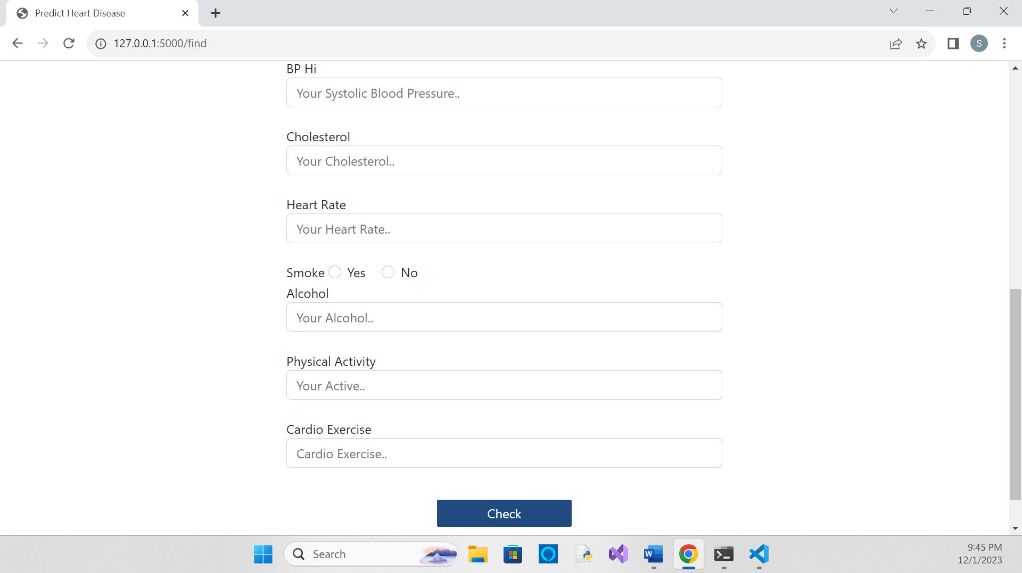

1. **Providing required inputs:**

**(Input with high-risk inputs)**

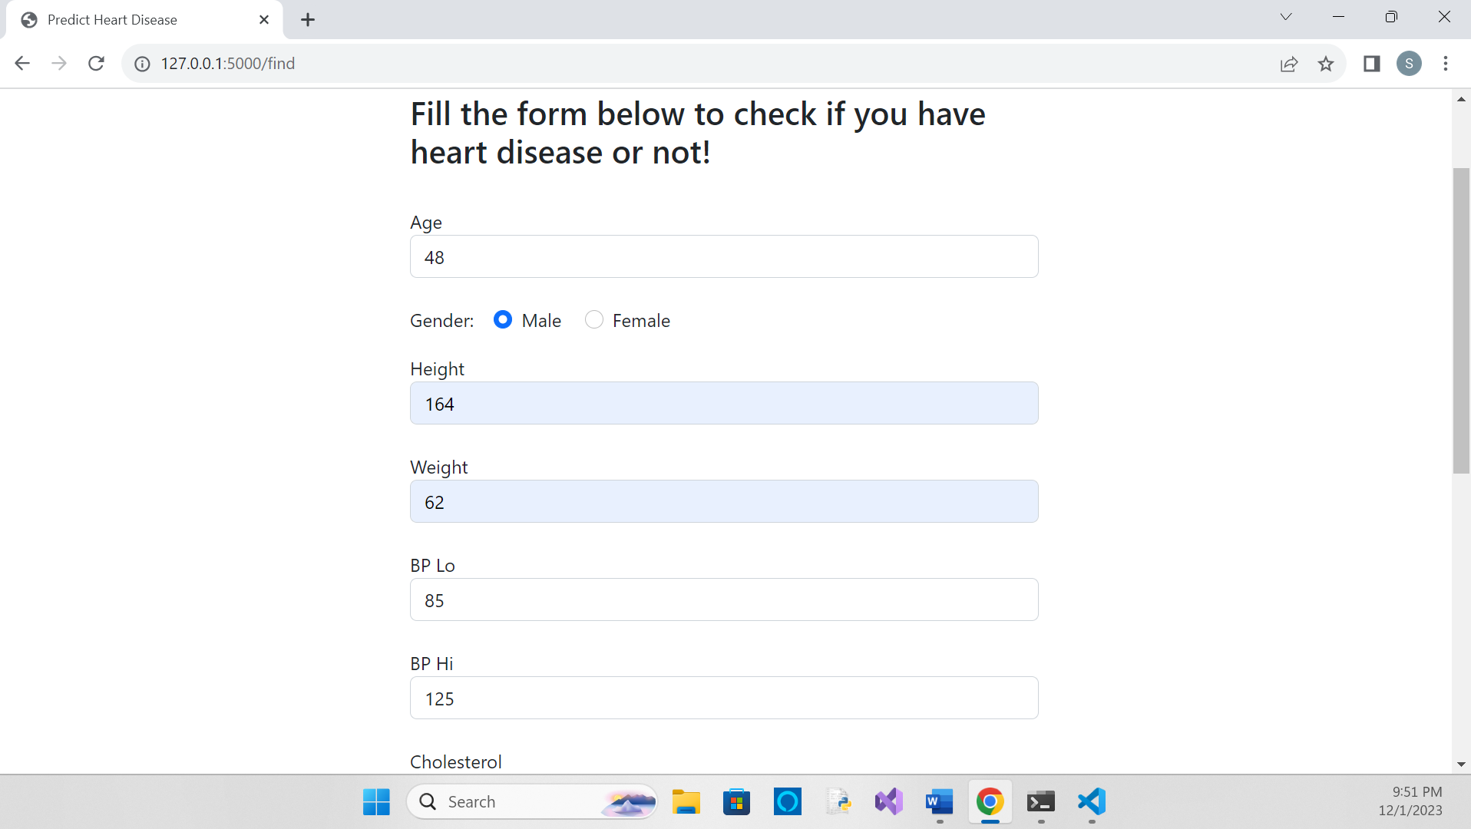

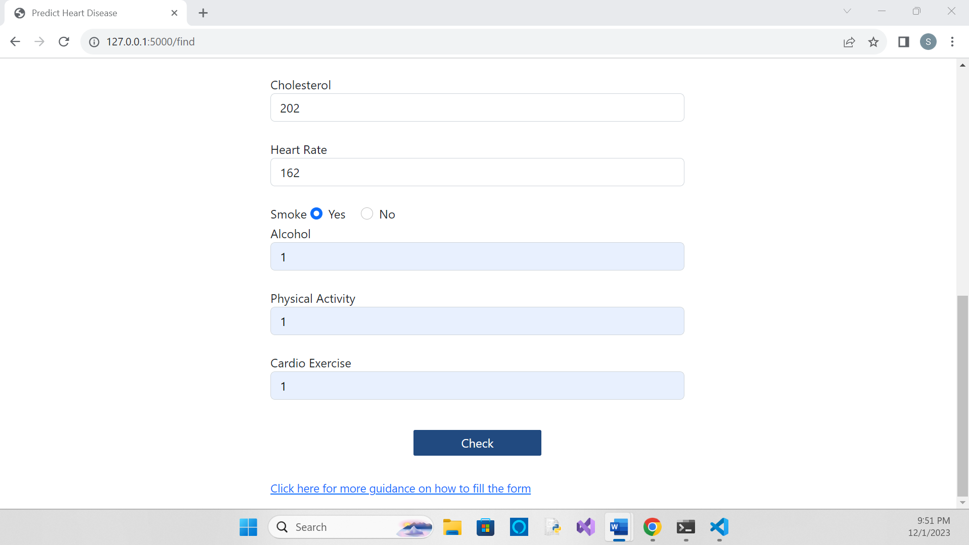

**(Input with low-risk input)**

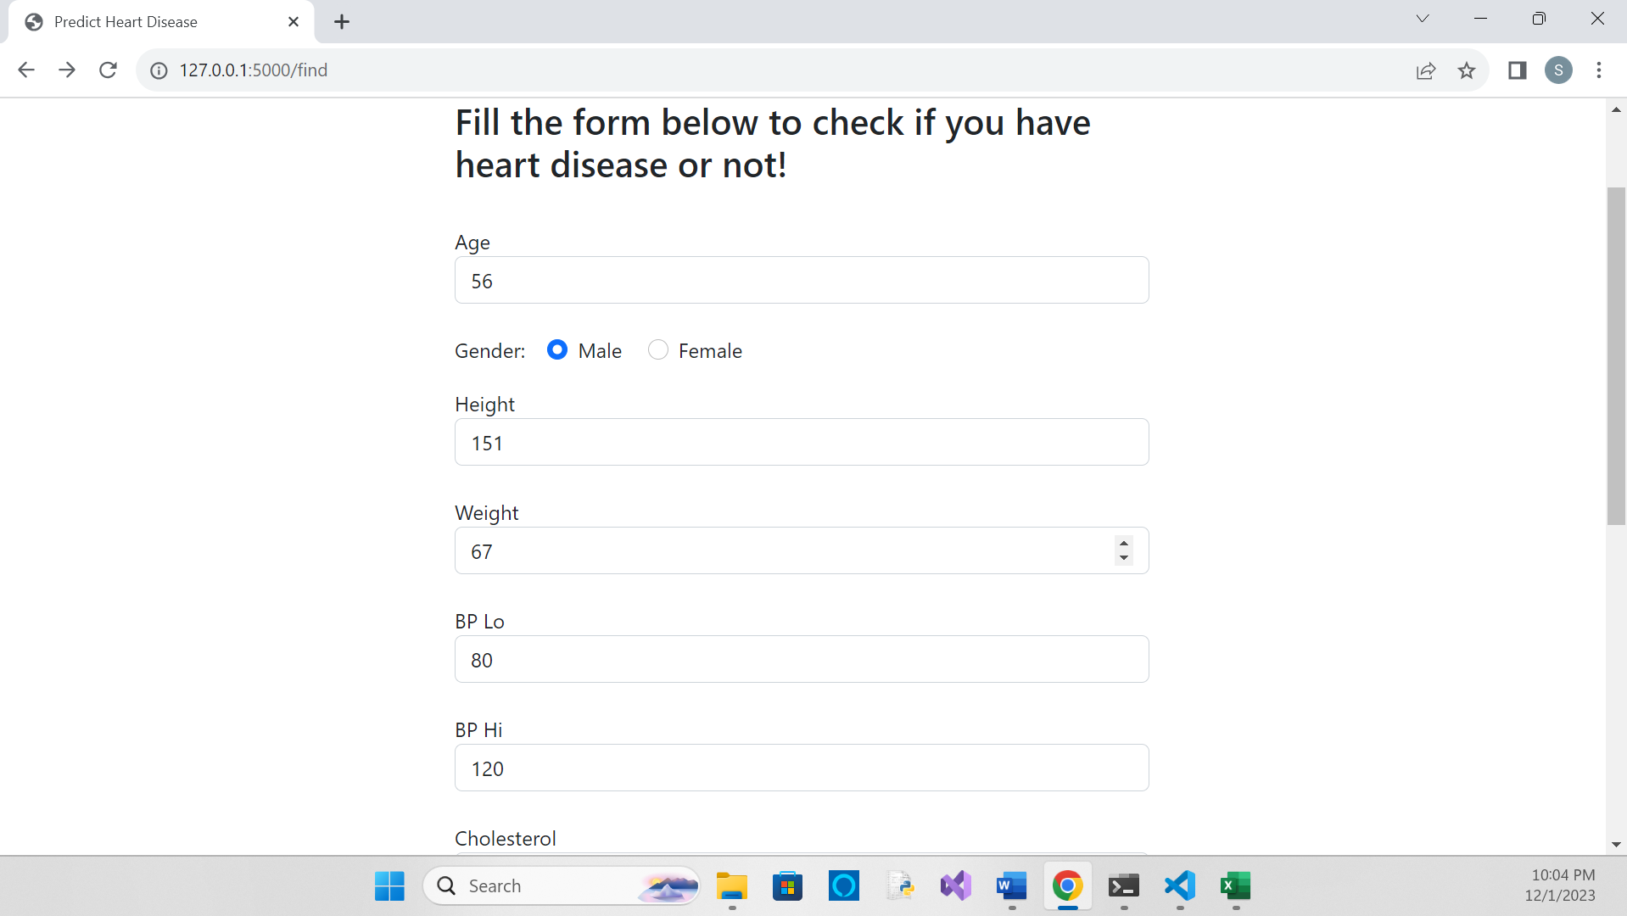

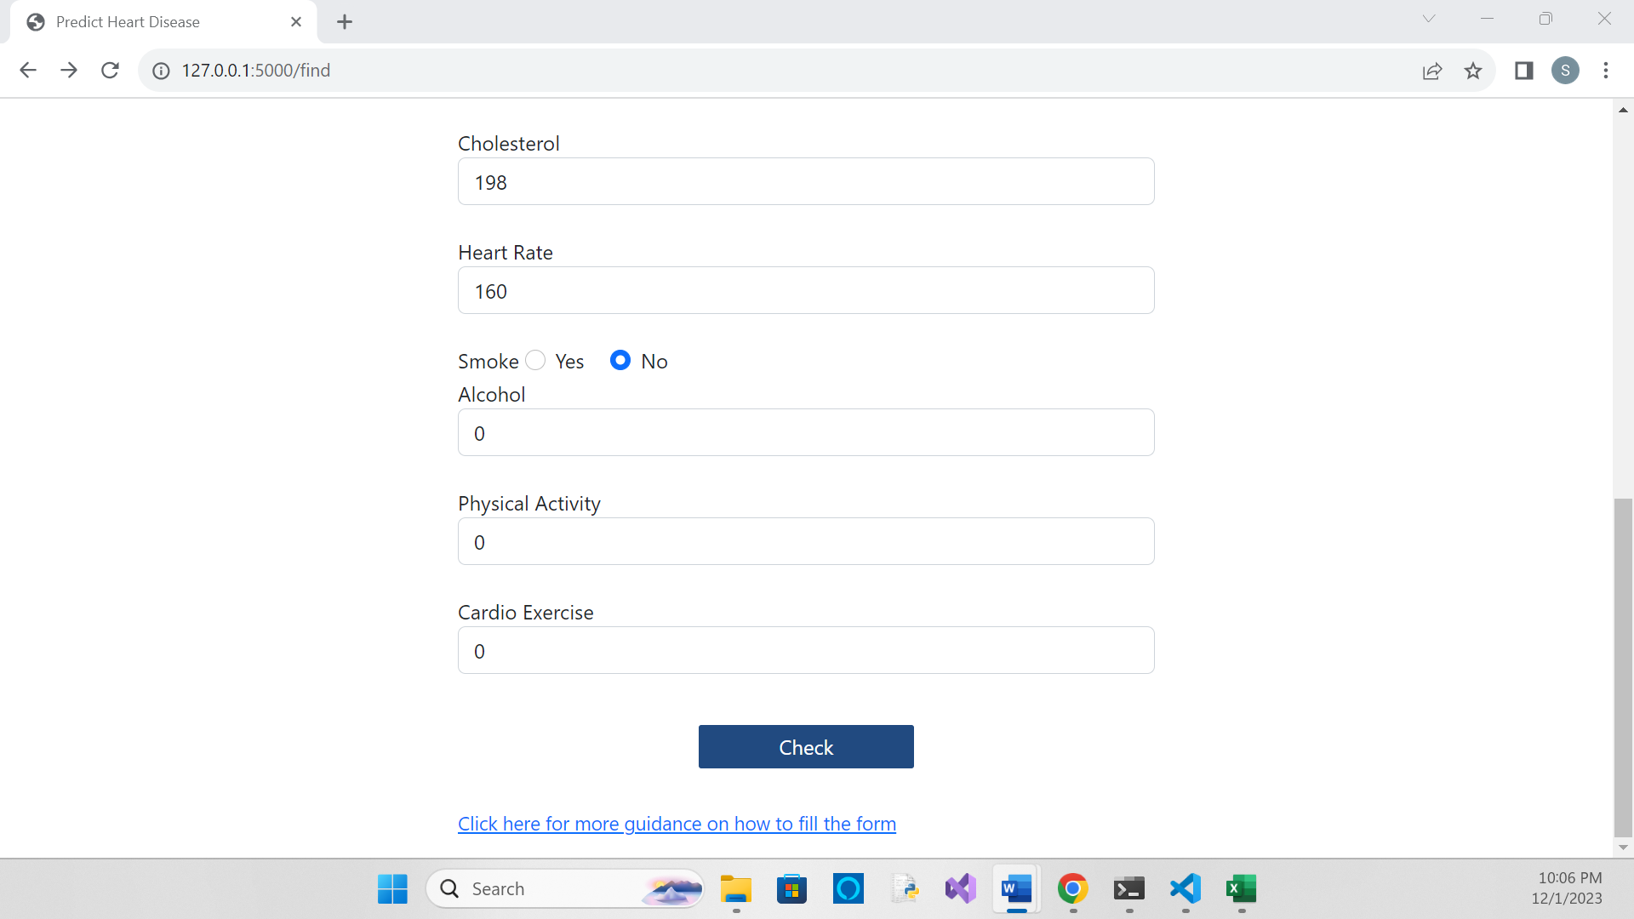

* 1. **Outputs**

**(With high-risk inputs)**

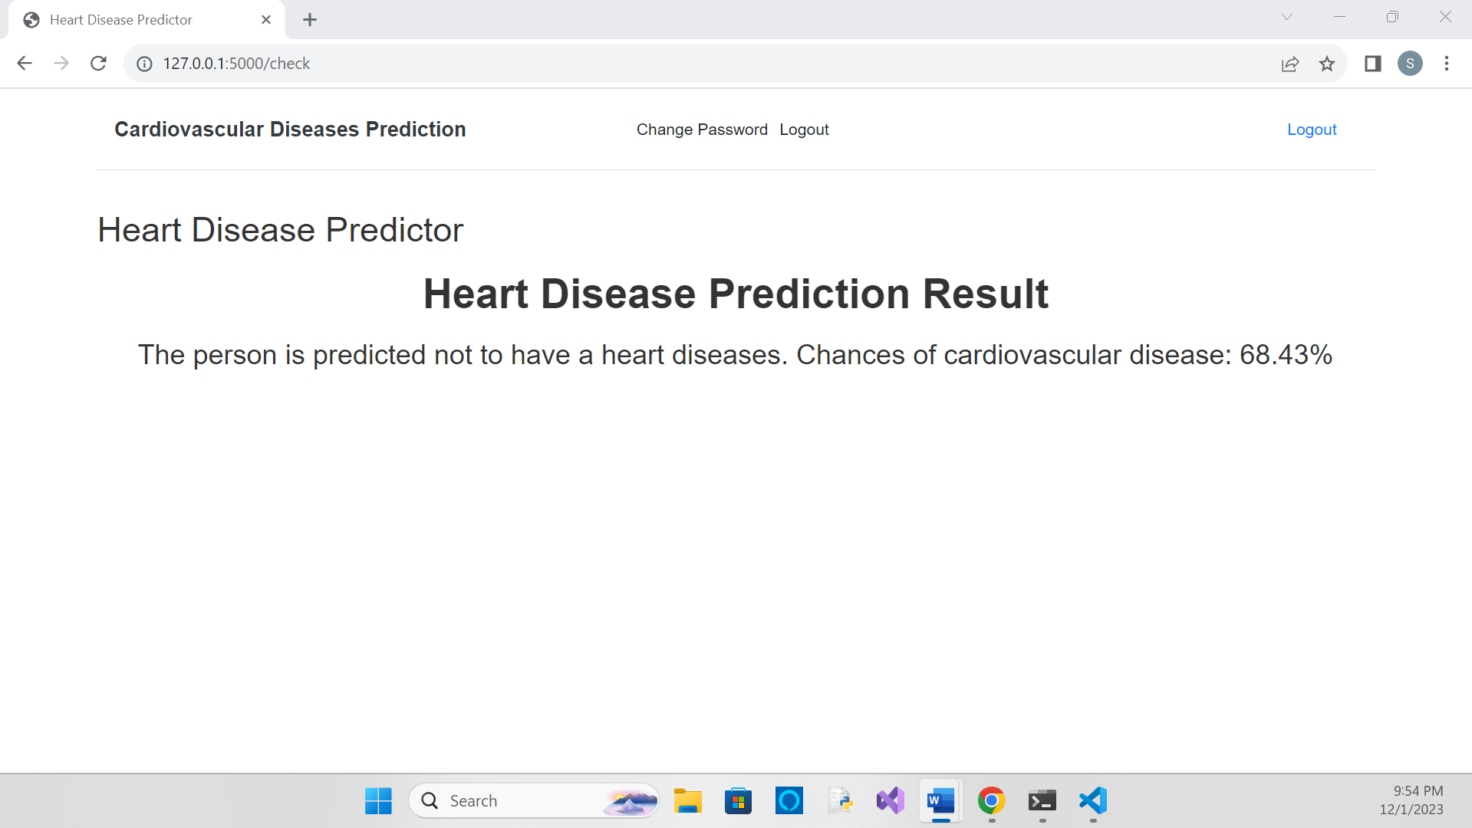

**(With low-risk inputs)**

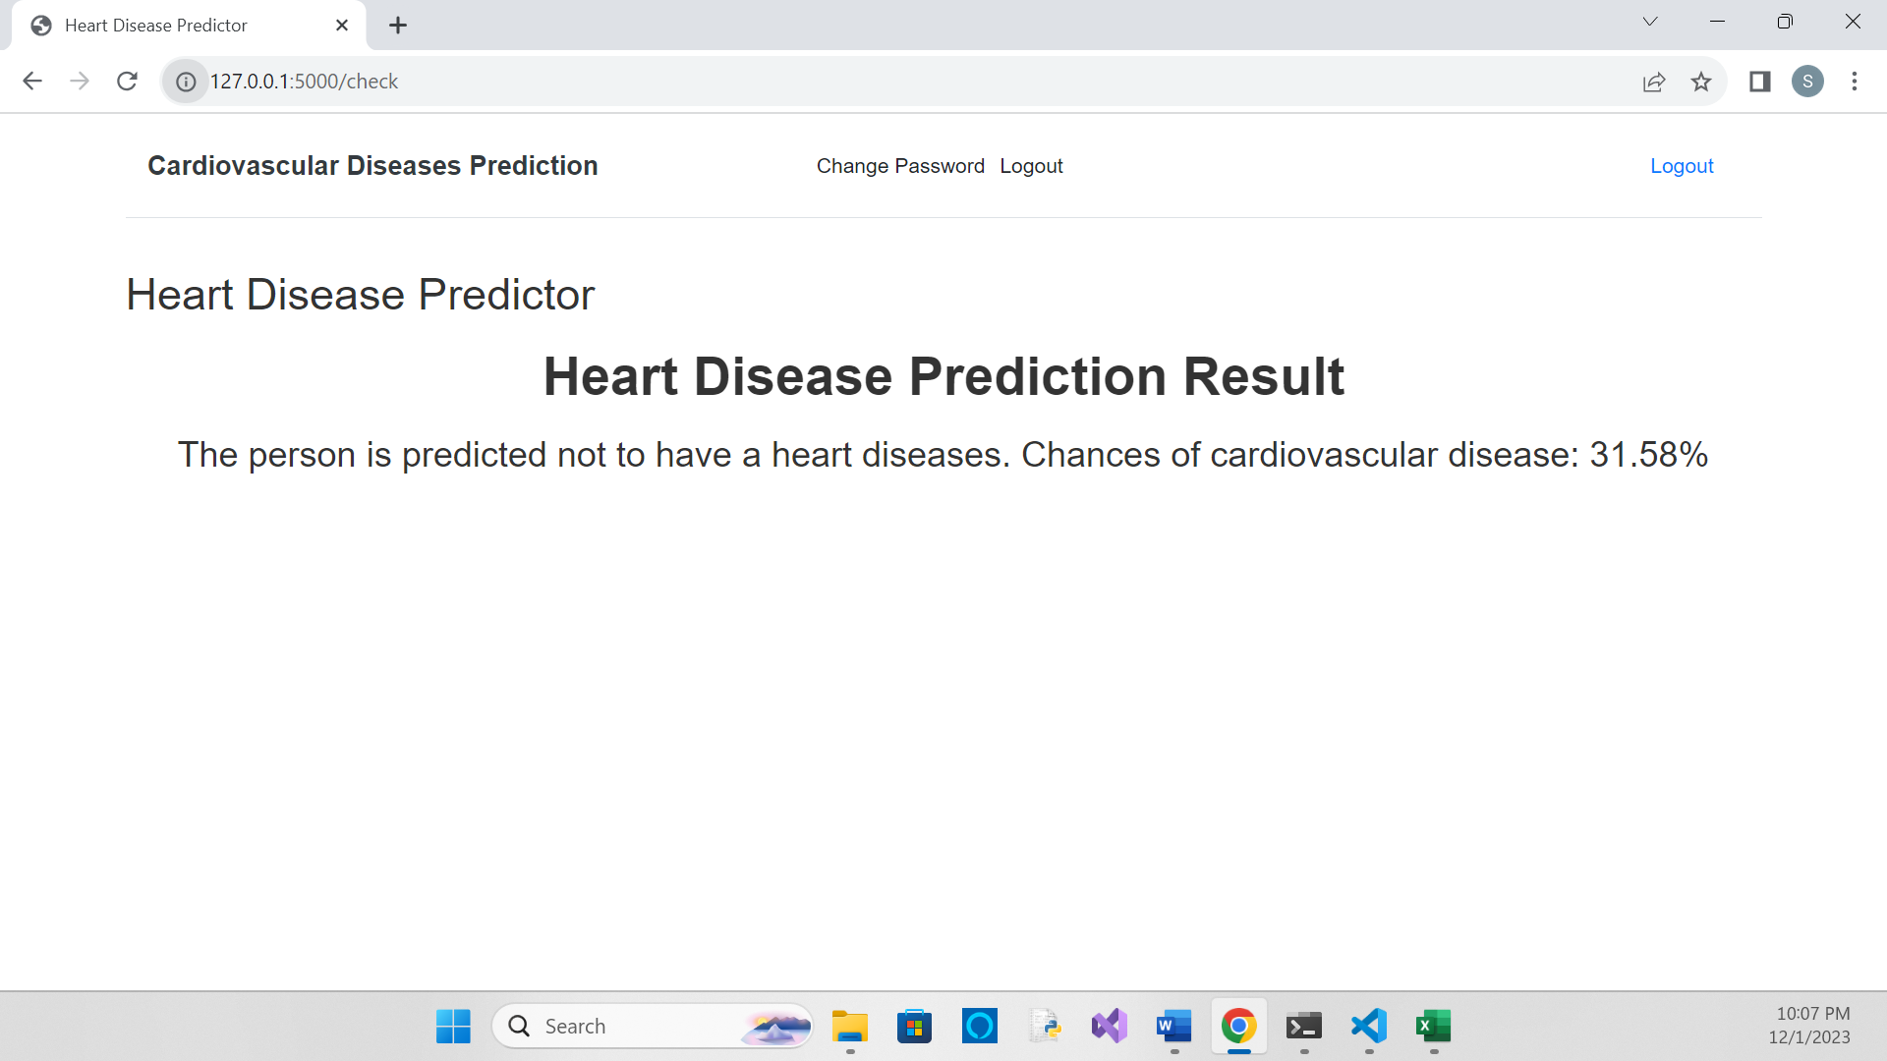

**Chapter 5**

**System Requirements**

**and**

**Implementation**

**5.1 System Requirement**

**Hardware:**

* Graphics Card: - 1650 or 1660TI

Performs ML or DL training and (often) inference, which is the capacity to automatically classify data based on learning, and is frequently an Nvidia P100 (Pascal), V100 (Volta), or A100 (Ampere) GPU for training and a V100, A100, or T4 (Turing) GPU for inference.

* CPU: - i5 9th or 10th Gen.

It is accountable for managing I/O, running the VM or container subsystem, and sending code to the GPUs. With the addition of features that considerably speed up ML and DL inference procedures, current-generation CPUs are now ready for production AI workloads using models that were previously trained on GPUs.

* Storage IOPS

Another performance barrier for AI workloads is the transfer of data between the storage and compute subsystems. As a result, local NVMe drives are more common than SATA SSDs in systems.

* RAM: - 16GB
* Intel’s ML Hardware Evolution
* PC

**Software:**

* Windows 10 and 11 (Intel/AMD 64-bit)
* Google Collaboratory
* Visual Studio Code
* Microsoft Excel
* Python IDLE

**5.2 Implementation**

**Phase I**

1. **Dataset Study:**

In order to train and test the model we have used a dataset comprising of almost 70k attributes. In the final project, the patients will have to provide data as per their test reports.

The dataset comprises of the following columns –

* Objective: factual information.
* Examination: results of medical examination.
* Subjective: information given by the patient.

**Dataset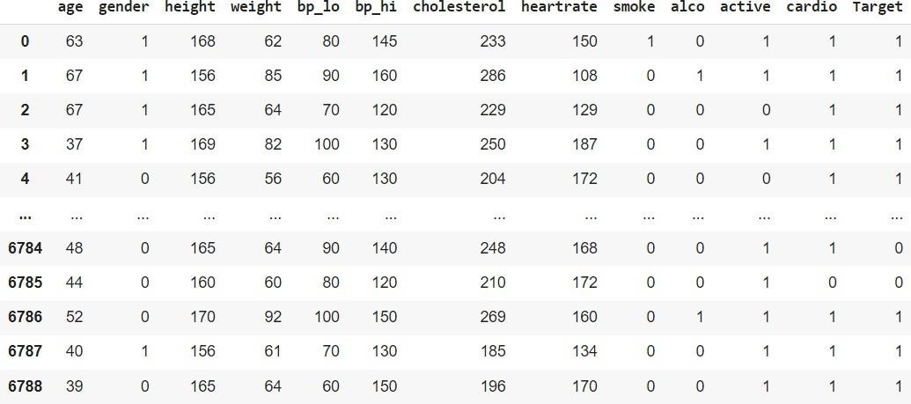:**

**Attributes:**

|  |  |  |  |
| --- | --- | --- | --- |
| Age | Objective | Age | Int (days) |
| Gender | Objective | Gender | Categorical code |
| Height | Objective | Height | Int (cm) |
| Weight | Objective | Weight | Float (kg) |
| Diastolic blood pressure | Examination | Bp_lo | Int |
| Systolic blood pressure | Examination | Bp_hi | Int |
| Cholesterol | Examination | Cholesterol | Int |
| Heartrate | Examination | Heartrate | Int |
| Smoking | Subjective | Smoke | Binary |
| Alcohol intake | Subjective | Alco | Binary |
| Physically Active | Subjective | Active | Binary |
| Cardio Exercise | Subjective | Cardio | Binary |
| Presence or absence of CVD | Target variable | Target | Binary |

After taking input from the user, we are going to pass it to the model that we have trained in order to receive accurate results regarding presence or absence of the heart disease.

1. **Performing EDA (exploratory data analysis)**

The dataset requires cleaning and modifying to facilitate easy access of data. For that purpose, we will perform EDA on null values and categorial values in the dataset.

1. **Feature selection**

Two of the 13 features in the data set—one each for age and sex—are used to identify the patient's personal information. The 11 remaining qualities are significant because they include crucial clinical records. Clinical data are essential for heart disease diagnosis and severity assessment. We chose blood pressure to be our target value based on whom we will carry out our analysis. We are also going to consider cholesterol and other parameters for more accurate results.

1. **Splitting data into train and test**

The project considered two main ways of data splitting one being using sklearn library and another approach is using cross validation or k-fold cross validation. The Sklearn train_test_split function helps us create our training data and test data. Whereas on the other hand, Cross-Validation or K-Fold Cross-Validation is a more robust technique for data splitting, where a model is trained and evaluated “K” times on different samples.

The value of k may be set as per the programmer’s choice.

The project mainly implements K-fold cross validation, the example for understanding which is as follows –

Suppose we have a balanced, 2-class dataset consisting of 1000 images of raccoons and ringtails (to be used for training and validation only). Now, we want to perform a 5-Fold cross-validation. We first split the datasets into 5 equal and non-overlapping parts: each consisting of 200 images; label them as Parts 1, 2, 3, 4, and 5. Each of these subsets of 200 images consists of mutually different samples.

Now, we will create 5 complete datasets (labeled as Datasets 1-5) using Parts 1-5 in the following manner: For Dataset-1, use Part-1 as the validation set, and consolidate Parts 2-5 to create the training set; for Dataset-2, use Part-2 as the validation set, and consolidate Parts 1, 3, 4 and 5 to create the training set, and so on. Notice that since each part consists of 20% of the data of the original dataset, each of Datasets 1-5 has an 80%-20% train-validation split ratio. Generalizing, each K-Fold cross-validation dataset has (100/K) % data in its validation set (here, 100/5 = 20% was in validation set).

**The images of the trained and tested dataset are as below –**

**Train –**

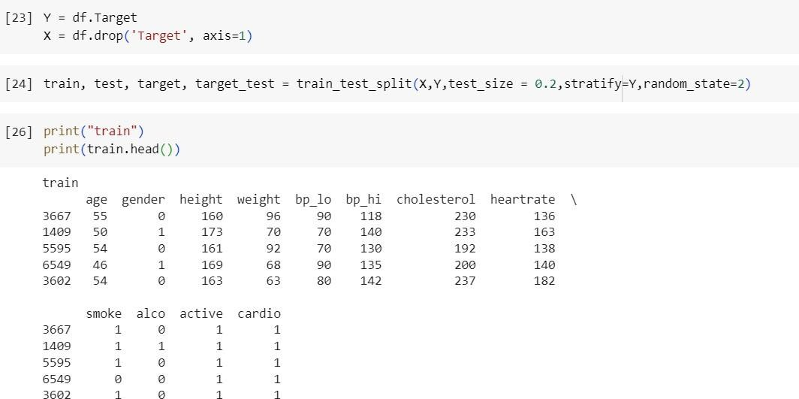

**Test –**

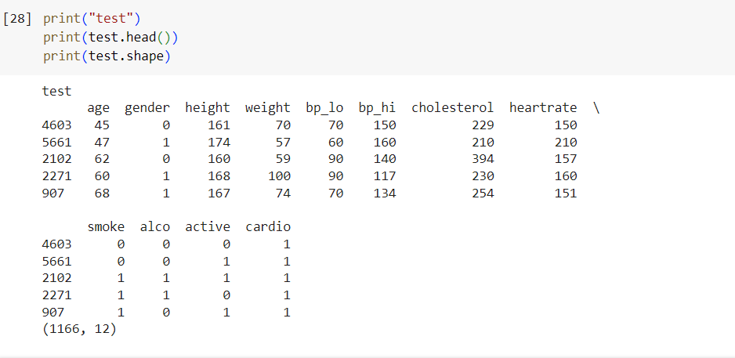

We have employed the sklearn library for splitting the dataset and the train dataset is 80% of the total while test is the remaining 20%.

1. **Evaluate and improve model accuracy**

Accuracy is a measure to know how well or badly a model is doing on an unseen validation set. Based on the current learning, evaluate the model on validation sets. We train and test the model with the help of the dataset that we have split. For that we have used algorithms like –

1. Logistic regression
2. K nearest neighbor
3. Random Forest
4. Neural Network
5. Perceptron
6. MLP
7. Decision Tree Classifier
8. SVM
9. Naïve Bayes

**Phase II**

**Front-end Part**

1. **HTML**

The Hyper Text Markup Language or HTML is the standard markup language for documents designed to be displayed in a web browser. It is often assisted by technologies such as Cascading Style Sheets (CSS) and scripting languages such as JavaScript.

HTML elements are the building blocks of HTML pages. With HTML constructs, images and other objects such as interactive forms may be embedded into the rendered page. HTML provides a means to create structured documents by denoting structural semantics for text such as headings, paragraphs, lists, links, quotes, and other items. HTML elements are delineated by tags, written using angle brackets. Tags such as <img /> and <input /> directly introduce content into the page. Other tags such as

<p> and </p> surround and provide information about document text and may include sub-element tags. Browsers do not display the HTML tags but use them to interpret the content of the page.

1. **CSS**

Cascading Style Sheets (CSS) is a style sheet language used for describing the presentation of a document written in a markup language such as HTML or XML (including XML dialects such as SVG, MathML or XHTML). CSS is a cornerstone technology of the World Wide Web, alongside HTML and JavaScript.

CSS is designed to enable the separation of content and presentation, including layout, colors, and fonts. This separation can improve content accessibility; provide more flexibility and control in the specification of presentation characteristics; enable multiple web pages to share formatting by specifying the relevant CSS in a separate .css file, which reduces complexity and repetition in the structural content; and enable the .css file to be cached to improve the page load speed between the pages that share the file and its formatting.

1. **Bootstrap**

Bootstrap is a free and open-source CSS framework directed at responsive, mobile- first front-end web development. It contains HTML, CSS and (optionally) JavaScript- based design templates for typography, forms, buttons, navigation, and other interface components.

Bootstrap is an HTML, CSS and JS library that focuses on simplifying the development of informative web pages (as opposed to web applications). The primary purpose of adding it to a web project is to apply Bootstrap's choices of color, size, font and layout to that project. As such, the primary factor is whether the developers in charge find those choices to their liking. Once added to a project, Bootstrap provides basic style definitions for all HTML elements. The result is a uniform appearance for prose, tables and form elements across web browsers. In addition, developers can take advantage of CSS classes defined in Bootstrap to further customize the appearance of their contents. For example, Bootstrap has provisioned for light- and dark-colored tables, page headings, more prominent pull quotes, and text with a highlight.

Bootstrap also comes with several JavaScript components which do not require other libraries like jQuery. They provide additional user interface elements such as dialog boxes, tooltips, progress bars, navigation drop-downs, and carousels. Each Bootstrap component consists of an HTML structure, CSS declarations, and in some cases accompanying JavaScript code. They also extend the functionality of some existing interface elements, including for example an auto-complete function for input fields.

1. **JavaScript**

JavaScript is a high-level, often just-in-time compiled language that conforms to the ECMAScript standard. It has dynamic typing, prototype-based object-orientation, and first-class functions. It is multi-paradigm, supporting event-driven, functional, and imperative programming styles. It has application programming interfaces (APIs) for working with text, dates, regular expressions, standard data structures, and the Document Object Model (DOM).

JavaScript engines were originally used only in web browsers, but are now core components of some servers and a variety of applications. The most popular runtime system for this usage is Node.js.

Although Java and JavaScript are similar in name, syntax, and respective standard libraries, the two languages are distinct and differ greatly in design.

1. **Flask**

Flask is a micro web framework written in Python. It is classified as a microframework because it does not require particular tools or libraries. It has no database abstraction layer, form validation, or any other components where pre-existing third-party libraries provide common functions. However, Flask supports extensions that can add application features as if they were implemented in Flask itself. Extensions exist for object-relational mappers, form validation, upload handling, various open authentication technologies and several common framework related tools.

1. **Prediction**

Test the model on unknown data or real-time data, After the system starts working properly, the model is complete.

**Back-end Part (Model Part)**

For the backend, that is for the actual cardiovascular disease prediction system, we developed a model where we have developed a model. The model is a classification model which will predict whether or not a person has heart disease.

However, this is not the objective of our major project. We wanted to develop a model which can also show the risk percentage along with the possibility of having a heart disease.

For that purpose, we have developed a full stack project, and have coded the risk prediction part separately which will be explained further.

**Libraries used:**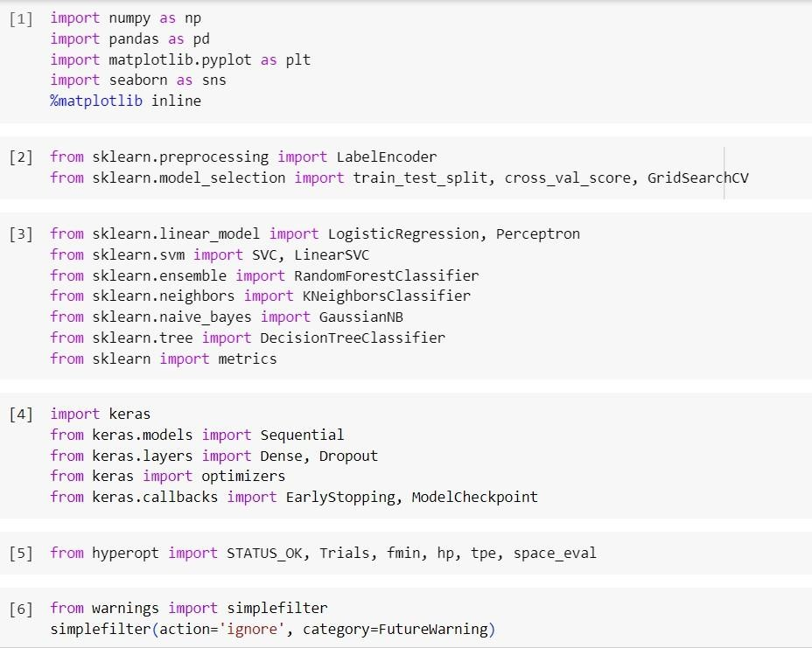

**Using the pandas library, we loaded the dataset which is as follows** –

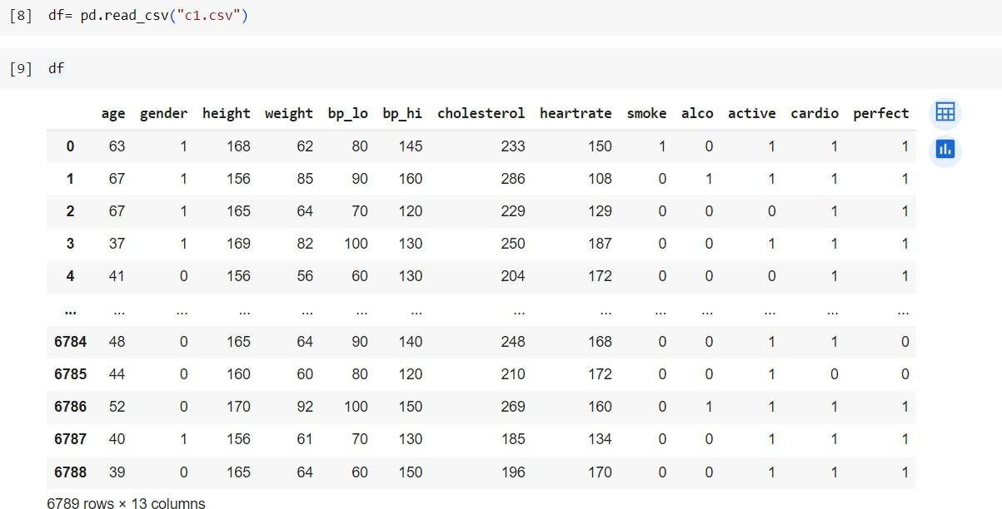

**Chapter 6**

**Reports**

I carried out some study of the dataset to understand the data better. I have plotted some graphs to study the same. The graphs and the codes for them are as follows.

**Graphs related to height and weight**

1. **For detecting outliers in height and weight**

**Code**

def outliers(df_out, drop = False):

for each_feature in df_out.columns: feature_data = df_out[each_feature]

Q1 = np.percentile(feature_data, 25.) # 25th percentile of the data of the given feature

Q3 = np.percentile(feature_data, 75.) # 75th percentile of the data of the given feature

IQR = Q3-Q1 #Interquartile Range

outlier_step = IQR * 1.5 #That's we were talking about above outliers = feature_data[~((feature_data >= Q1 - outlier_step) &

(feature_data <= Q3 + outlier_step))].index.tolist()

print('For the feature {}, No of Outliers is {}'.format(each_feature, len(outliers)))

outliers(df[['height', 'weight']])

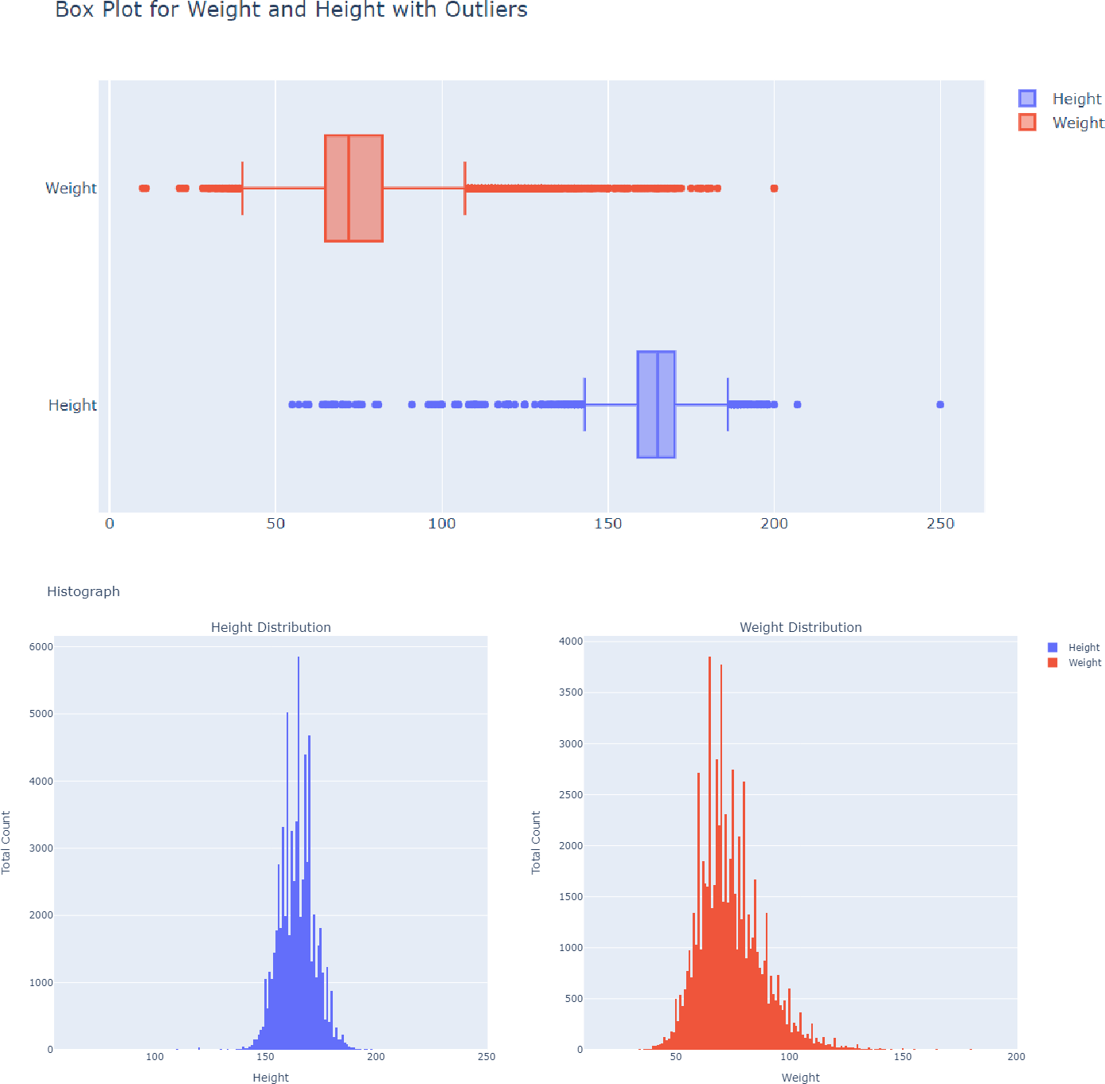

1. **Graph for distribution of height and weight of a person with cardiovascular disease and without cardiovascular disease**

fig = make_subplots(rows=2, cols=2, subplot_titles=("Height Distribution for CVD Population", "Height Distribution for non CVD Population", "Weight Distribution for CVD Population", "Weight Distribution for non CVD Population"))

trace0 = go.Histogram(x=np.exp(df[df['cardio'] == 0]['height']), name = 'NonCVD') trace1 = go.Histogram(x=np.exp(df[df['cardio'] == 1]['height']), name = 'CVD')

trace2 = go.Histogram(x=np.exp(df[df['cardio'] == 0]['weight']), name = 'NonCVD') trace3 = go.Histogram(x=np.exp(df[df['cardio'] == 1]['weight']), name = 'CVD') fig.append_trace(trace0, 1, 1)

fig.append_trace(trace1, 1, 2)

fig.append_trace(trace2, 2, 1)

fig.append_trace(trace3, 2, 3)

fig.update_xaxes(title_text="Height", row=1, col=1) fig.update_yaxes(title_text="Total Count", row=1, col=1)

fig.update_xaxes(title_text="Height", row=1, col=2) fig.update_yaxes(title_text="Total Count", row=1, col=2)

fig.update_xaxes(title_text="Weight", row=2, col=1) fig.update_yaxes(title_text="Total Count", row=2, col=1)

fig.update_xaxes(title_text="Weight", row=2, col=2) fig.update_yaxes(title_text="Total Count", row=2, col=2)

fig.show()

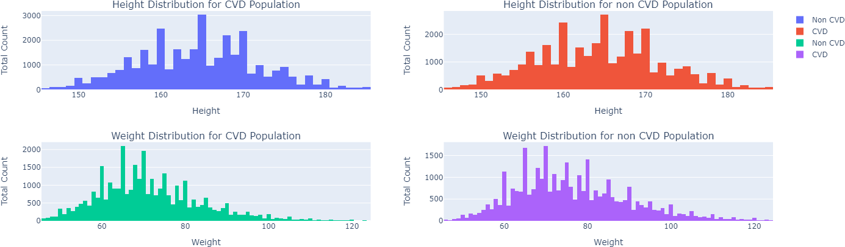

**Graphs related to blood pressure**

1. **Graph to understand the distribution of people with and without cardiovascular disease against their systolic and diastolic blood pressures**

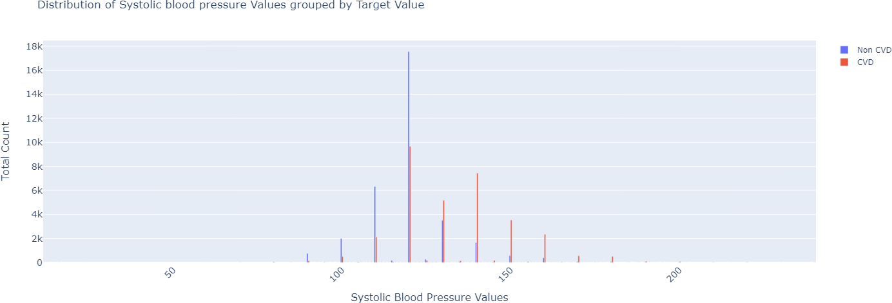

1. **Graph of distribution of systolic blood pressure for people without cardiovascular disease**

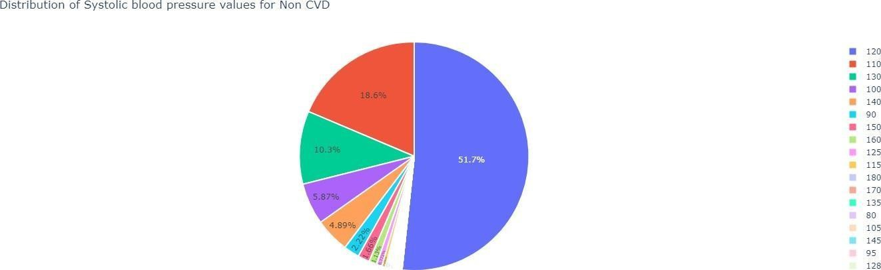

1. **Graph of distribution of diastolic blood pressure for people with cardiovascular disease**

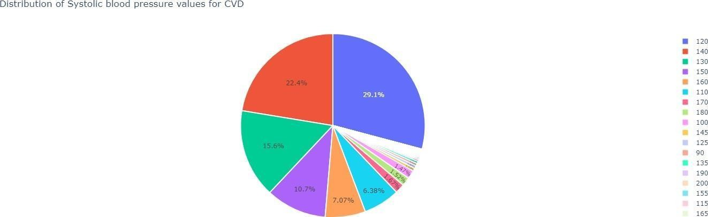

1. **Graph of count of people to understand whether or not they have cardiovascular disease with the normal values – (diastolic)**

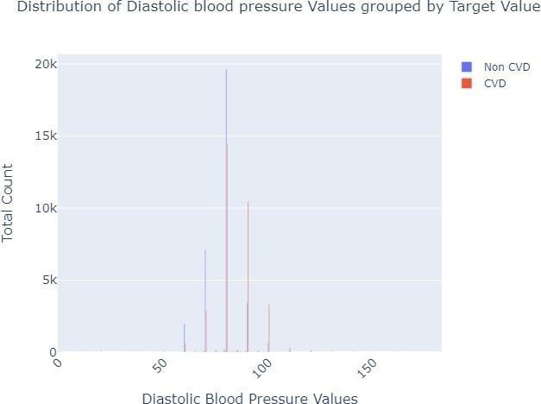

1. **Graph to understand the diastolic blood pressure ranges for people that do not have cardiovascular disease – (diastolic)**

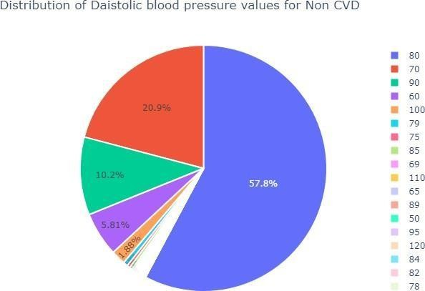

1. **Graph to understand the diastolic blood pressure ranges for people that have cardiovascular disease – (diastolic)**

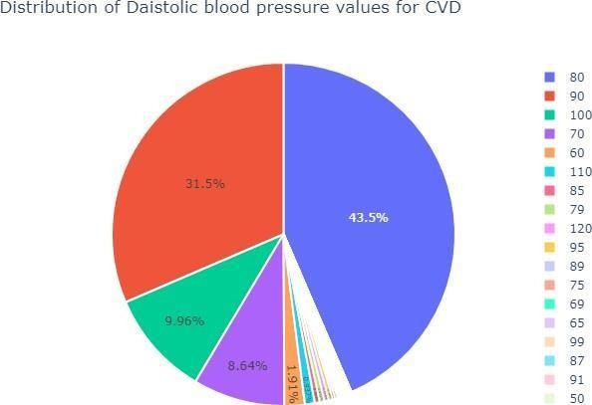

1. 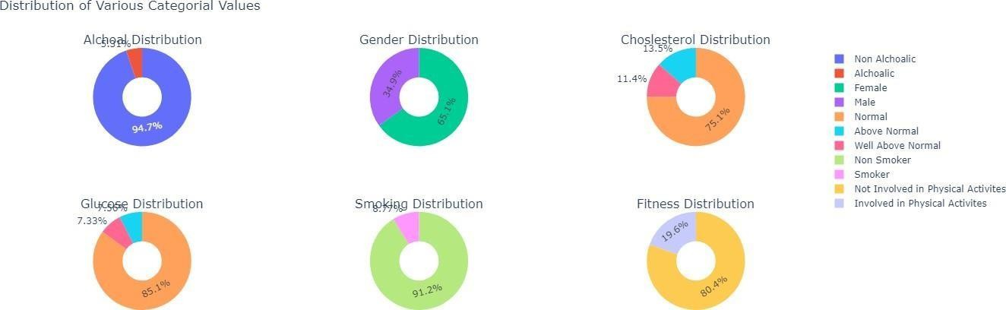**Graph to show the distribution of all the categorical values in the dataset considered**
2. **Graph of severity level of cholesterol, glucose, smoke, alcohol intake and physical activity with the count of people in that severity range**

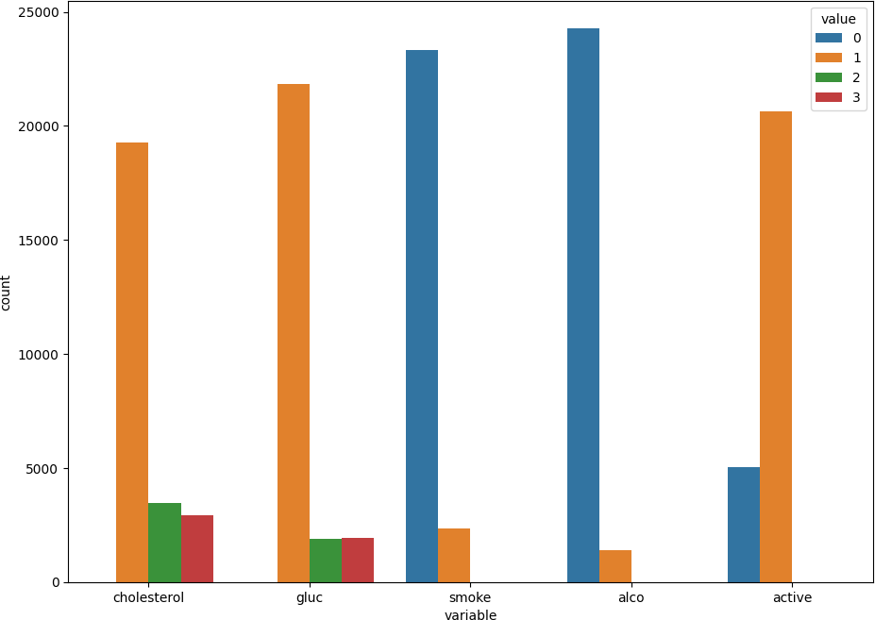

**Graphs related to age factor**

1. **Graph to study the age group and the gender which mainly suffer from cardiovascular disease.**

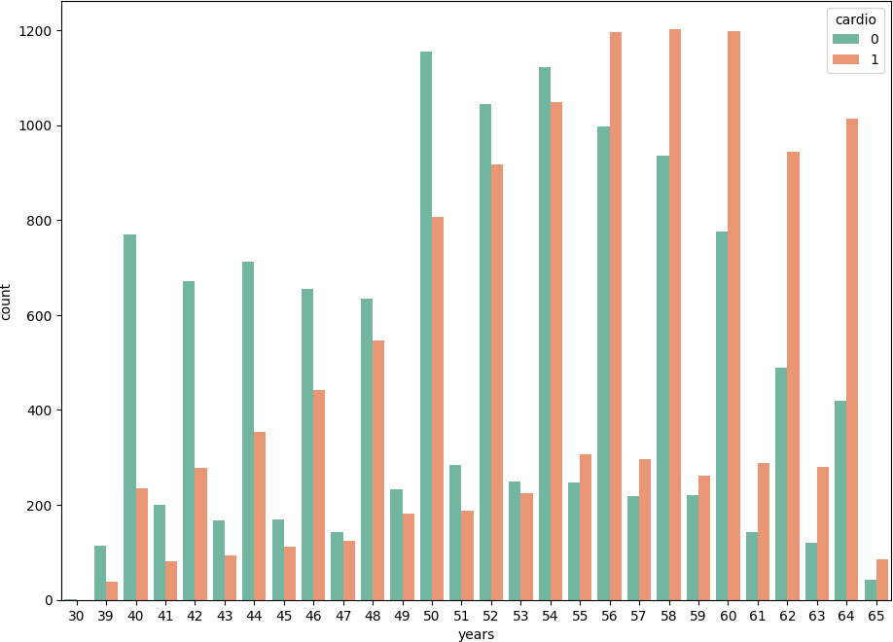

**Accuracy of all the models can be understood through the following –**

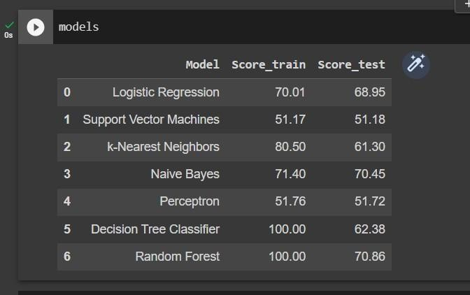

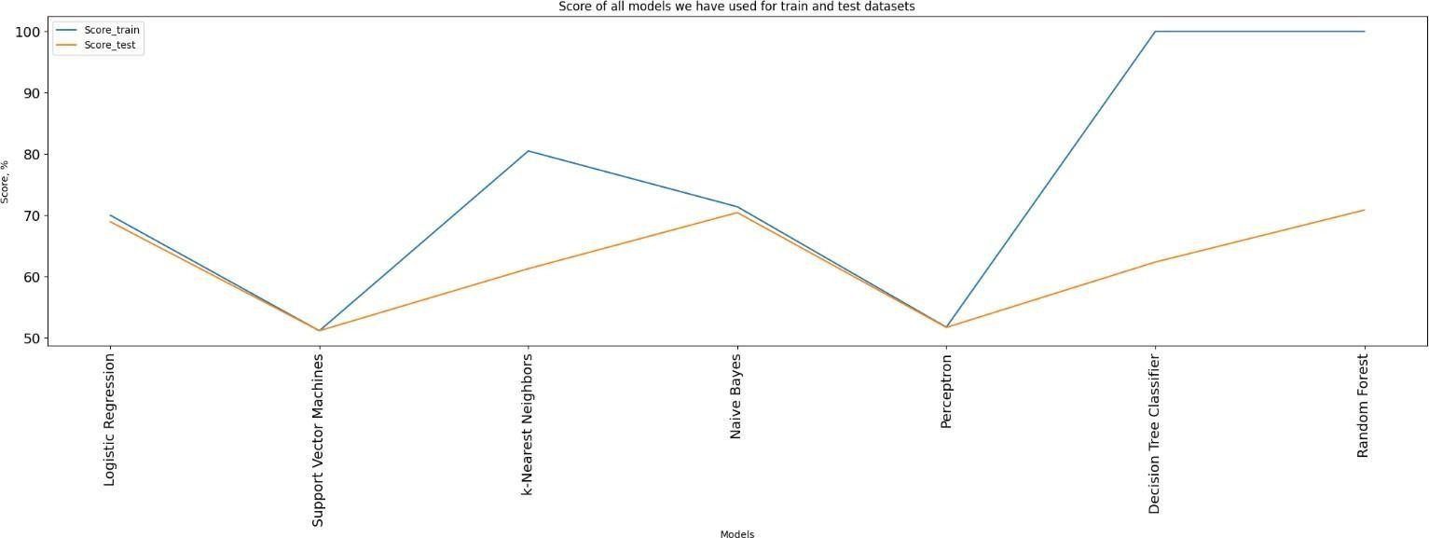**Line Graph:**

Fig. line graph

**Bar Graph:**

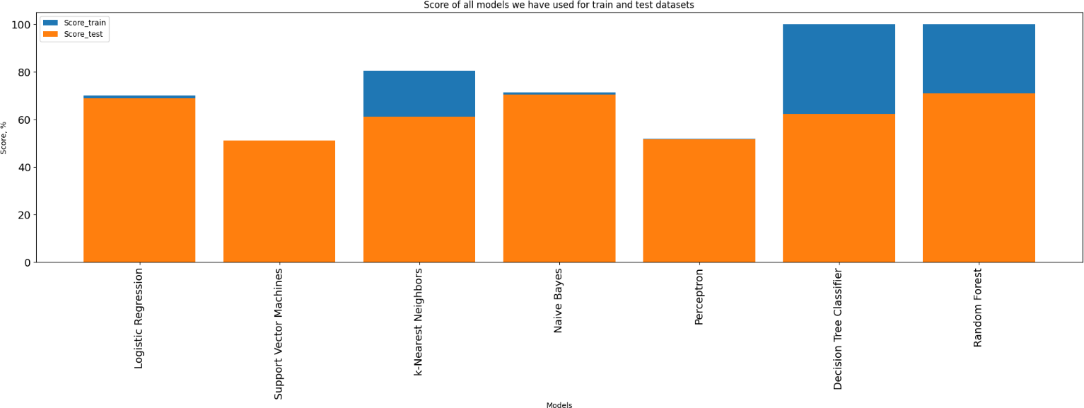

Fig. bar graph

We have finally selected Random Forest to be the model which we will use to make predictions because it gave us the highest accuracy –

For training we received – 100 %

For test we received – 70.86 %

**The graph of random forest is as follows –**

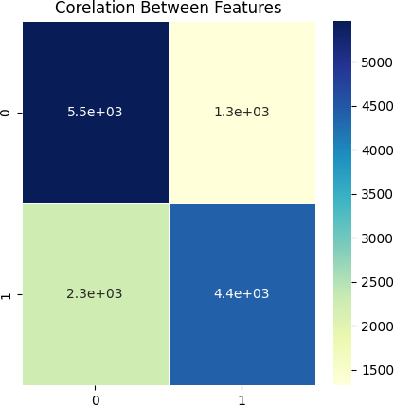

Fig. confusion matrix of random forest model

**Chapter 7**

**Conclusion**

**And**

**Future Work**

Identifying the processing of raw healthcare data of heart information will help in the long-term saving of human lives and early detection of abnormalities in heart conditions. Machine learning techniques were used in this work to process raw data and provide a new and novel discernment towards heart disease. Heart disease prediction is challenging and very important in the medical field. However, the mortality rate can be drastically controlled if the disease is detected at the early stages and preventative measures are adopted as soon as possible.

Through this project we have made an honest effort to use various machine learning algorithms in order to get maximum accuracy which is very important in healthcare sector.

There are various applications of Heart Disease Prediction using Machine Learning. Some are mentioned below:

In the medical industry, when practitioners or patients need to monitor a patient's heart rate for a variety of reasons.

This model might be applied when it's necessary to assess heart rate or other heart related conditions prior to major surgery. Furthermore, even before the patient receives the necessary medical attention, this model can be used to identify the risk and severity of cardiac disease.

Using the website users can also see whether they are having any risk of heart disease by entering their report details on the website.

In the future a more elaborate project can be build using deep learning techniques and data mining techniques not only for heart disease prediction but also for covering other diseases.

Various other techniques of ML can also be implemented in order to develop a more efficient model. In this project we have only created a website but a mobile application can also be created for easier access.

**Chapter 8**

**Annexure**

1. **Joining Report**



1. **Weekly Progress Report**

**Weekly Progress Report 1**

|  |  |
| --- | --- |
| Name of Student | Mr. Pattankude Shailesh Surendra |
| Title of the Project | Cardiovascular Diseases Prediction |
| Name of Guide | Mr. Rohan S. Suryawanshi |
| Organization | Softron |
| Date of joining Organization | 10th Aug 2023 |
| Date of Progress Report | 10th Aug 2023 To 16th Aug 2023 |
| Period of progress Report | 7 Days |
| Progress:   1. Introduction To HTML, CSS, JavaScript, Python 2. Problem Identification. 3. Project Topic Finalization. 4. Submission of Synopsis. | |

**Signature of Student Signature of Industry Guide**

**Weekly Progress Report 2**

|  |  |
| --- | --- |
| Name of Student | Mr. Pattankude Shailesh Surendra |
| Title of the Project | Cardiovascular Diseases Prediction |
| Name of Guide | Mr. Rohan S. Suryawanshi |
| Organization | Softron |
| Date of joining Organization | 10th Aug 2023 |
| Date of Progress Report | 17th Aug 2023 To 23th Aug 2023 |
| Period of progress Report | 7 Days |
| Progress:   1. Introduction to MySQL. 2. Basic Commands in MySQL 3. Function of MySQL 4. Introduction to Flask | |

**Signature of Student Signature of Industry Guide**

**Weekly Progress Report 3**

|  |  |
| --- | --- |
| Name of Student | Mr. Pattankude Shailesh Surendra |
| Title of the Project | Cardiovascular Diseases Prediction |
| Name of Guide | Mr. Rohan S. Suryawanshi |
| Organization | Softron |
| Date of joining Organization | 10th Aug 2023 |
| Date of Progress Report | 24th Aug 2023 To 30th Aug 2023 |
| Period of progress Report | 7 Days |
| Progress:   1. Collecting dataset 2. Installing Flask 3. Overview of HTML, CSS, JavaScript 4. Introduction to Bootstrap | |

**Signature of Student Signature of Industry Guide**

**Weekly Progress Report 4**

|  |  |
| --- | --- |
| Name of Student | Mr. Pattankude Shailesh Surendra |
| Title of the Project | Cardiovascular Diseases Prediction |
| Name of Guide | Mr. Rohan S. Suryawanshi |
| Organization | Softron |
| Date of joining Organization | 10th Aug 2023 |
| Date of Progress Report | 31st Aug 2023 To 6th Sep 2023 |
| Period of progress Report | 7 Days |
| Progress:   1. SRS Submission and Approval. 2. Cleaning Dataset 3. Task on Frontend development. | |

**Signature of Student Signature of Industry Guide**

**Weekly Progress Report 5**

|  |  |
| --- | --- |
| Name of Student | Mr. Pattankude Shailesh Surendra |
| Title of the Project | Cardiovascular Diseases Prediction |
| Name of Guide | Mr. Rohan S. Suryawanshi |
| Organization | Softron |
| Date of joining Organization | 10th Aug 2023 |
| Date of Progress Report | 7th Sep 2023 To 13th Sep 2023 |
| Period of progress Report | 7 Days |
| Progress:   1. Training Dataset 2. Use case Diagram 3. State Diagram 4. Sequence Diagram | |

**Signature of Student Signature of Industry Guide**

**Weekly Progress Report 6**

|  |  |
| --- | --- |
| Name of Student | Mr. Pattankude Shailesh Surendra |
| Title of the Project | Cardiovascular Diseases Prediction |
| Name of Guide | Mr. Rohan S. Suryawanshi |
| Organization | Softron |
| Date of joining Organization | 10th Aug 2023 |
| Date of Progress Report | 14th Sep 2023 To 20th Sep 2023 |
| Period of progress Report | 7 Days |
| Progress:   1. Testing Dataset 2. Deployment Diagram 3. Activity Diagram 4. Completed Database Design in MySQL | |

**Signature of Student Signature of Industry Guide**

**Weekly Progress Report 7**

|  |  |
| --- | --- |
| Name of Student | Mr. Pattankude Shailesh Surendra |
| Title of the Project | Cardiovascular Diseases Prediction |
| Name of Guide | Mr. Rohan S. Suryawanshi |
| Organization | Softron |
| Date of joining Organization | 10th Aug 2023 |
| Date of Progress Report | 21st Sep 2023 To 27th Sep 2023 |
| Period of progress Report | 7 Days |
| Progress:   1. Creating Pickle File 2. Input Design Completed. | |

**Signature of Student Signature of Industry Guide**

**Weekly Progress Report 8**

|  |  |
| --- | --- |
| Name of Student | Mr. Pattankude Shailesh Surendra |
| Title of the Project | Cardiovascular Diseases Prediction |
| Name of Guide | Mr. Rohan S. Suryawanshi |
| Organization | Softron |
| Date of joining Organization | 10th Aug 2023 |
| Date of Progress Report | 28th Sep 2023 To 4th Oct 2023 |
| Period of progress Report | 7 Days |
| Progress:   1. Output Design Completed. 2. Completed Report Generation. | |

**Signature of Student Signature of Industry Guide**

**Weekly Progress Report 9**

|  |  |
| --- | --- |
| Name of Student | Mr. Pattankude Shailesh Surendra |
| Title of the Project | Cardiovascular Diseases Prediction |
| Name of Guide | Mr. Rohan S. Suryawanshi |
| Organization | Softron |
| Date of joining Organization | 10th Aug 2023 |
| Date of Progress Report | 5th Oct 2023 To 10th Oct 2023 |
| Period of progress Report | 6 Days |
| Progress:  1. Project Presentation to the company. | |

**Signature of Student Signature of Industry Guide**

1. **Student Guide Meeting Record**

**GUIDE STUDENT MEETING RECORD**

Student Name: - Mr. Pattankude Shailesh Surendra

Contact No.: - +91 7721916221

Guide Name: - Mrs. Navni P. Chougale

Contact No.: - +91 9850908991

Topic: - Cardiovascular Diseases Prediction

Industry Name: - Softron Technology

Industry Guide Name: - Mr. Rohan Suryawanshi

Designation: - CEO

Contact No: - +91 7276702802

|  |  |  |  |  |
| --- | --- | --- | --- | --- |
| **Sr. No.** | **Date** | **Description** | **Signature of Institute Guide** | **Signature of Student** |
| 1 |  | Problem identification, Topic finalization Submission of synopsis. (First week of Inplant training) |  |  |
| 2 |  | SRS submission and approval (Fourth week of Inplant training) |  |  |
| 3 |  | Logical design of system  (DFD, System flowchart, ERD, UML diagram, Decision tables, Decision tree etc. which is applicable) (Fifth week of Inplant training) |  |  |
| 4 |  | Database Design  (Sixth week of Inplant training) |  |  |
| 5 |  | I/O Design  (Eight week of Inplant training) |  |  |
| 6 |  | Submission of First Draft (Second week of Sem III) |  |  |
| 7 |  | Submission of Second Draft (Fifth week of Sem III) |  |  |
| 8 |  | Submission of Final Draft (Tenth week of Sem III) |  |  |

|  |  |  |  |  |
| --- | --- | --- | --- | --- |
| **Sr. No.** | **Date** | **Description of Discussion** | **Signature of Institute Guide** | **Signature of Student** |
| 1 |  |  |  |  |
| 2 |  |  |  |  |
| 3 |  |  |  |  |
| 4 |  |  |  |  |
| 5 |  |  |  |  |
| 6 |  |  |  |  |
| 7 |  |  |  |  |
| 8 |  |  |  |  |

**Director**

**Synopsis**

**Feedback**

**Chapter 9**

**References**

**References**

* <http://ieeexplore.ieee.org/xpl/articleDetails.jsp?arnumber=6864427&newsearch=true&queryText=disease%20prediction>
* <http://ieeexplore.ieee.org/xpl/articleDetails.jsp?arnumber=6395001&newsearch=true&queryText=disease%20prediction>